27 – On saying yes to prostitutes
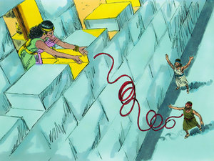
Rahab, the Bible’s prostitute
Page numbers for main sections:
2 - My youth's relationship with prostitutes
6 - My Changing Relationship with Prostitutes in the United States
9 - How prostitutes saved my life
13 - How pimps and more helped me from armed rebellion against the Nixon administration
16 - How I ended up sleeping with my first black prostitute
31 - On my escape from world-renowned artist to artistic call girl
37 - On my betrayal of Martha, the streetwalker in Harlem
43 - On my own fall and defeat in the meat ghetto
56 - On my new life with the prostitutes - now seen from above
69 - On hearing the cry for help from the prostitutes
77 - How I spent all my money on Jamaica's prostitutes
91 - My attempt to help prostitutes ended with my escape from them
107 - Conclusion and my opposite ends of prostitution
1. My youth's relationship with prostitutes

I have always wondered where the contempt - even hatred - for prostitutes comes from. Besides, of course, the Bible's antiquated view that woman was a man's property, who should work for him, why women who rebelled by seeking an independent income had to be condemned, even literally stoned to death on top of the already moral stoning. I myself, however, was more influenced by the New Testament attempt to rebel against this oppression of women in the few passages where Jesus forgives these women sinners. They and other sinners like the Samaritans were somehow the only thing that seeped into my sleeping thick head in church, as easily understood as these messages were in their black and white images.
And yet I'm not even sure that as a child I understood the word "sinners" to mean prostitutes or harlots, since nowhere does Jesus directly refer to them as such. Unlike the Old Testament, where "harlot" is mostly used by the prophets as an image of Israel's decay. So what evidence do we really have that Jesus forgave prostitutes when "sin" includes so many other things that we all commit? Such as adultery, which is not a profession, but where Jesus says to the one caught "sin no more." Hm, can you break your marriage more than once, you think? Or whether Mary Magdalene was a prostitute when nowhere is she referred to as such until a pope found out she was - probably to repent her own visit to a brothel.
So as an adult I also rebelled against my father's church in disappointment that Jesus in his imagery didn't nurture a little more transparent treatment of prostitutes through his own example 😊
For example, if Jesus had had the courage to tell parables in which he gives 1 denarius to one prostitute and 5 denarii to another (i.e. women who, as outcasts, are left with no other means of supporting themselves) - rather than constantly giving them to (debt-)bound male servants and day labourers - well, at least there would have been a feminist rebellion and attempt at empowerment and an equally recognizable trafficking in human beings within a historically conditioned master-slave relationship.
Yes, yes, I know that these parables are about other things and more, but you shape people by the images you create of them.
So when, despite my Christian upbringing to believe in forgiveness, I nevertheless developed early prejudices against prostitutes, surely a damning Christian preaching is as much to blame for that as myself and the prostitutes. I certainly remember how we schoolchildren used words like "whores" out in the country - though not as far as I remember about emancipated women having sex before marriage, in the way that many of our immigrants today perpetuate the Old Testament view that prevailed in their homelands. For us, it was not a matter of social control - although in other ways it was exercised by many of the farming families over whom their children could marry. My nanny, Solvej, for example, was not allowed to have the fishmonger's son for her father, Søren Thomsen Sørensen, who as parish council chairman was more respected. But they were allowed to have sex with each other before marriage, etc.
No, whore was probably just a dirty word that was fun for us boys to put in our mouths - except for me, who was a priest's son and "too fine" to use such terms. I think the first time I heard the term about a real whore was when the boys were talking about our classmate Judith's mother being a whore. We never went to her dilapidated poor house on the hill down by the fishery, and I think there was as much sympathy as condemnation when it was whispered about. At the time of writing - 60 years later - Margit Soltau, a classmate of mine, says that she and Else Marie remember being at Judith's house and seeing the terrible mess and neglect once, and that her older brothers were forbidden by her parents to visit Judith's mother, though I don't think she understood the reason at the time. In our class picture, Judith does appear to be the most neglected and none of us in the class have seen or heard from her since school.
In high school, I went on a drinking trip to Copenhagen with some friends during an autumn holiday, mostly because I had a good eye for the naughty Karen Sjørup from the parallel class. One evening we ended up in a very drunken state in the then sinful Nyhavn, where a lush older prostitute grabbed me and dragged me out onto the dance floor in front of the others. I was so awkward and clumsy that I blushingly pinched the easy-living lady forcefully in the back to get free but remember nothing else and have since wondered if my reaction was a reflection of my condescending view of prostitutes or my always dour relationship with women as a teenager. Perhaps I feared that Karen Sjørup would see me dancing around with a dejected pleasure girl, but she does not remember being with me that sinful evening and has ever since set herself up as the great feminist and expert on gender and equality, during which 40-50 years later I still sat opposite her at boring meetings and tried in vain to get her attention.

As a young immigrant from West Jutland in Vesterbro, I loved hanging out with the old prostitutes in the late hours of the night in the neighborhood’s beverages, especially the Greenlandic "table whores" at Postillonen and in Tunesia in Istedgade. Sociologically, it was exciting for me to "get down" with them, as the younger ones were too busy for outside chitchat in the morning hours. I often ended up here on my way home from the more intellectual nightclubs where my peers hung out in the inner city because I hadn't found a girl to go home with. Or some bluff quiet girl from the northern sleeping towns of the upper classes had followed me home, and to loosen her up or drag out the chores, I dragged her along to Istedgade, where I instead lost myself in the far more exciting stories of the old prostitutes while my own dates fled home. These sex workers were as natural a part of the wallpaper on Vesterbro as the porn shops and massage clinics, which also held no interest for my generation.
Even the child porn we did not react to, as it was only much later that we became aware of the aftermath for the children. Although I often heard Greenlandic whores in particular talk about how they had been subjected to blood shame in childhood, I had too much ass on both ends to put two and two together. I only remember one time when I followed a crying and wobbly Greenlandic whore home to her lobster around Matthæusgade, but without staying very long and talking in the early hours of the morning.
With my later experiences in the US, I can see how we 68ers let down both the prostitutes and the abused children by passively using their presence around us as proof of our freethinking, but without offering them any help or compassion at all. Some tried to dodge responsibility by seeing them as products of their parents' generation or as symptoms of a rotten class society.

2. My changed relationship with prostitutes when I came to the US

This view, which also stemmed from the welfare state's idea that if there were social problems, "it was society's fault" in the sense that the welfare state then had to correct and fix its little mistakes by always being in the making, was what I arrived with in the United States. And for a long time, I used that as a cynical excuse not to get involved with the individual suffering person like the prostitutes, but just to coldly resent that here was no kind of institutionalized help for them. Thus, I was also blind to how many warm helping hands - such as in churches - there actually were in this "let fall what cannot stand" society, and which among other things also helped myself to get better in touch with my human side. Therefore, it was a slow process for me to learn to integrate with this group - the prostitutes - which was partly reciprocal, as they had no immediate particular need to integrate with me.
Indeed, for a long time I only met them in the street scene at night standing in their high-heeled shoes and short skirts, where they could see from a distance that I was not a potential customer. So they quickly brushed me off as a waste of time if I tried to have a chat about their lives, whereby we developed mutual prejudices about each other, even though their whole unassuming demeanor was an unmistakable cry for help. A bit like whites in the US believing that blacks will reject them and Danes the same about immigrants and wrongly concluding that the minority doesn't want integration.

My prejudice came from making judgments about prostitutes based on their immediate situation and not on their deeper needs and desires, i.e. by not really seeing them as people at all. Only when, during my nightly ghetto wanderings, I met the most worn-out, old drug addicts and they abused my curiosity to lure me into dingy dark truck parks, did I come into close contact to a fifth degree with these mysterious creatures. As a rule - as in science fiction - not a single human word was communicated when they suddenly pulled out my unidentified flying object and kneeling began to suck it off in the hope of just a few dollars. Nor were they interested in delaying small talk when - empty-handed, grasping at the slightly too volatile object - they quickly realized they had gorged themselves on someone as empty-handed as themselves.

No, as with every other group I've integrated with, it only moves when you move in with the people you're prejudiced against. And as with most others, this was not something I did consciously, but a result of saying yes to people who invited me in. It was easy enough with women in general - especially white women - and for a long time I only discovered that some of them were prostitutes when, after some time or when I later returned, they told me about it. Only former prostitutes, though, I think, who had now calmed down somewhat and confessed that they had picked me up as a Danish divorcing hitchhiker because they sensed that I wasn't out for sex. Thus I always felt like a virgin beach washer washed up on virgin shore in relationships with prostitutes. Although some of these later became lesbians, it was clear that they needed to talk to a man with whom they did not have a business relationship in order to restore their confidence in men. Through long conversations with them, I began to understand how devastating it had been for them to be prostitutes. Especially for their self-esteem. But most of these were white and had not walked the streets. Some had just thrown themselves into it to pay for the expensive tuition at university and seemed to have got off reasonably well by virtue of being able to see a higher purpose in it. As it seemed a free choice to them, I didn't take it very seriously for the first two years on the road, still thinking more ideologically than humanly.

3. How the prostitutes saved my life
A turning point came when, as planned, in 1972 I left the United States "forever" to hitchhike to Guatemala and join the guerrilla struggle against the United States. But it was like stepping straight into the dead zone with barricades, violence everywhere, starving children, machine guns in the back against the wall under constant searches and a completely closed population that didn't dare to speak out. The Indians in the mountains, in particular, were so terrified that it was a death sentence in itself to even ask where the guerrillas were. I soon concluded that even if they were to win one day, they would be so corrupted in this circus of death that they would simply perpetuate the violence under their own ideologies. Fortunately, I did not find the guerrillas out in the mountains and sought out the port city of Puerto Barrios to think about what I was going to do. In doing so, I ended up in the arms of the local prostitutes who were waiting for needy sailors. And these merrymakers were just what I needed in my depression, as they were the first to talk to me in the entire country. Unlike the prostitutes in the US, they certainly had plenty of time to take care of me as we sat together in the harbor bars scouting for ships. In their eyes, I was not a long-haired moneyless hippie who was not worth betting on, because here in bloody Guatemala, long hair carried the death penalty, as only guerrillas had it. So with short hair and neatly trimmed beard, white shirt and tie I appeared in their eyes as the incarnate Yankee businessman no doubt loaded with money. And though they had been put in their miserable position by the poverty and oppression the guerrillas claimed to fight, they had no use for their form of salvation, which threatened to destroy their business.
And what imaginary money can't buy, I now discovered. They threw themselves at me from all sides, gave me drinks and groped me everywhere, and though I didn't know Spanish, I've rarely had so much fun and felt so much in heaven while the tropical rain hammered down and cut me off from escape to my whore hotel for a dollar a night. I was so annoyed to have spent a whole dollar with all the offers of free accommodation I was now getting, as it was against my vagabond principles to spend money on shelter. But since I had a hard time choosing between all the wonderful offers for fear of hurting others or what would happen when they discovered I had no money, I ended up fleeing my little heaven to redeem the dollar I had invested in the country as a businessman. But they were a happy turning point in the midst of the disillusionment I found myself in the dawning realization, which they were now helping to bring about, that I was going to have to give up my naive youthful dream of joining the hard-boiled world ideological guerrillas. For they made me realise that life's real, present and fun people were the ones I should instead bet on in my path ahead. I have since wondered where I would be today if I had happened to fall into the arms of a charismatic guerrilla soldier who had been able, through camaraderie, to give me the sense of finding an identity and belonging in a group - in the midst of this searching confusion of mine - in the same way that so many of today's searching youth end up in identity-giving terrorist cells. These prostitutes, on the other hand, helped me to feel that I should choose life over death.
And they did so in enticing English, for when one of their American clients had left them a copy of Time magazine, I read therein that there would be large demonstrations at Nixon's Republican convention in Miami. This further helped me to abandon my mad venture to join them in eagerly scouting for rescue ships so that I could escape by banana boat to Miami. But as their loving embraces became more and more desperate when no ships appeared, I eventually ended up having to use the apostles' horses to escape - not only from guerrillas and the military, but also from these saving angels of light of mine.
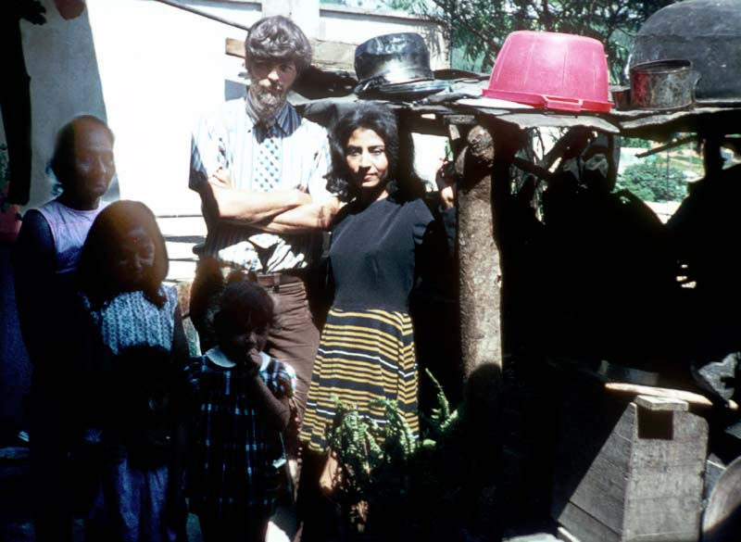
With my short-haired wig and coiled beard, I bid a sad farewell to my saving maidens of joy.

On 9 August I chose to go back through the bloody jungle all the way north back to "the belly of the monster". And in just 6 days I hitchhiked with the short-haired parrot through Mexico and the dreaded southern states down to Miami to fight the monster Nixon from within - the man who as Vice President in 1954 had started all this carnage in Guatemala.
As I wrote in the diary:

Wednesday, August 9, 1972 - Puerto Barrios, Guatemala
All night in bars with the prostitutes. Heavy rain. Up at 7am. Talked to United Fruit about ship apartment, but not possible. Saw port captain, but not home. Got pass at 11 for port, where they loaded bananas. Had to wait till 1 to get pictures of the workers. Then gave up and hitchhiked out of town. First with prisoner transport. So I hitchhiked back with the soldiers, but they didn't understand me. Gave up and was picked up by the American writer I met the night before. Fanatical anti-communist. He talked all the way about freedom in Guatemala, while we were stopped everywhere by machine guns....

So not being able to choose between prostitutes may be an eye and door opener to Heaven, because after them my next lodging was with one of America's wealthiest women, who as a Republican delegate let me share her hotel room in the very luxury headquarters, The Fontainebleau, of the greatest terrorist of the time, President Nixon.

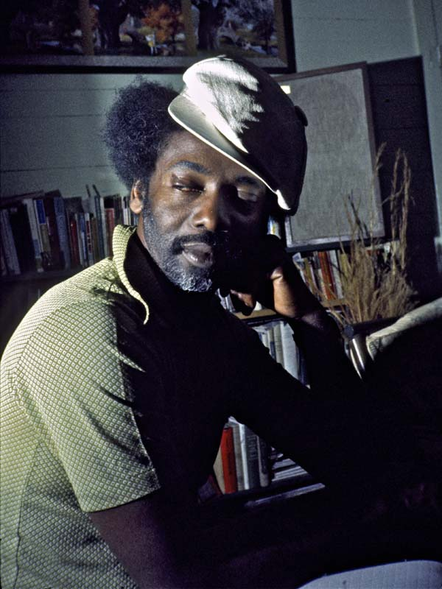
4. How the pimp helped me from armed rebellion against the Nixon administration
Funnily enough, my problem with choosing between prostitutes the following year was also part of the reason I eventually opted out of terrorism. Here it was a black pimp who opened my eyes to the whole oppression behind prostitution. I described it in a letter to an American friend:
"The day I left the big plantation homes in Mississippi after several weeks, I came to stay with a black pimp in Greenville in the poor delta area. We became quite good friends, and he said that because of our friendship he would give me one of his prostitute girls. I said nothing. He took me to a bar where four of his girls were standing. "Pick the pussy you want. You can have it for free," he said. I didn't know what I was going to do for a living. I love black prostitutes, this whole amazing mix of violent brutality and heartfelt tenderness. You can learn more about society from a black prostitute in one night than from ten university lectures. But it was impossible for me to choose.
So Ed, as he was called, took me back home. From then on, he became more open, and it turned out he had put me to the test. He was very interested in the things I had told him, but he had never met a white man he trusted, and now he wanted to see if I was like the other whites in Mississippi. That night was one of my most violent experiences yet. We both lay in the bed he usually used for his business, and all night he told me about his childhood. It all came as a revelation to me. It was my first time in Mississippi, and it probably seemed extra powerful because I had just spent two weeks in the big plantation homes with the big antebellum dresses and gold and pewter all over the place. He told me about the hunger, about how he had had to pick cotton from the age of five for $2 a day, about how he hadn't gone to school properly because he had to pick cotton, and about all the humiliation he had constantly had to put up with from the whites. Now he just didn't feel like it anymore. Hell no, he repeated over and over. He wanted to get away from this cotton hell. That was why he had become a pimp. Both he and his girls agreed that it was better to prostitute themselves in this way than to prostitute themselves in the cotton fields. It was the white man who took the profit in both cases, but they just earned much more this way: $15 a night per girl. He had studied the white man all his life, his every move and thought. He felt he knew the white man better than he knew himself, and yet he did not understand him. But his experience made him a good pimp, even though he was only 19. He knew exactly how to put the white men in touch with his girls. But it hurt him to do it. He felt deeply hurt at having to do it. He felt he was selling his race and his pride, but he had no choice. He hated the white man with all his heart, oh how he hated him. But he never dared show it. That night it dawned on me that if the average Mississippi Negro felt like Ed, there would come a day when things didn't look good for whites. I was so shaken after that night that for the next few days I didn't dare look whites in the eye. I had been lucky that day that someone had given me batteries for my tape recorder. I therefore recorded a large part of what he said. Now, when I travel among Mississippi whites and stay with them, I often play this tape for myself in the evenings. I don't want to identify too strongly with their views. With their charming accents and strong human warmth, it's hard not to be seduced. It's all about keeping a cool head in the boiling pot of the South.
I took it as a coincidence that he opened up to me, when I had mostly wanted to go with the prostitutes. But now I'm beginning to think it wasn't a coincidence. It's like something keeps leading me into the right situations."
I was on my way up to participate in the Indian uprising at Wounded Knee, but again this intense event there helped me to opt out of the rebellion and instead throw myself into the arms of people who needed me, as described in "On Saying Yes to the Indians." For only two days and 2,000 miles after I lay with a black pimp in the Southern heat, I lay - first with an Indian girl and the next day, on my 26th birthday - with a gay Indian, as described in the diary.

Friday, April 27 - Greenville, MS at Edward the Pimp, 445 Maple St.
Hitchhiked from Greenville up through the Delta to Memphis, where I stayed until afternoon. Got caught in the rain. Got a lift with negroes out of Arkansas. Then took a ride with a sailor all the way to St. Louis at 8 o'clock. Proceeded at night to Kansas City, where at 1 a.m. I was invited to spend the night in a middle-class home. Mother horrified at my pictures.
Saturday, April 28 - Kansas City, MO at the home of Malcolm Kharr, 4109 Locust
Got a ride at 8 am out to the highway and hitchhiked up through Iowa to Sioux City and Falls. Then took a ride all the way through South Dakota with a young guy. In Rapid City at 8 we went into a bar where I had promised to find the guy a place to stay. Got talking to two Indian girls who said I could stay with them, but not with him. They drove me home and fed me. Diane Tyrrell said I could sleep in her bed.

Sunday, April 29 at Wounded Knee Supply Camp....
5. How I ended up sleeping with my first black prostitute
The letter about my night with Edward the pimp was written sometime after, because at that point I hadn't actually had intimate experiences with black prostitutes to justify the silly phrase, "I love black prostitutes....." My first real breakthrough came five months later when, in my attempt to get to the tobacco harvest in eastern North Carolina, I had "agreed" to a ride to the other end of the state and ended up in Greensboro. To show that at no time had I dreamed of sleeping with a prostitute, let me tell you about the accidental "foreplay" that led me into the can with one. In Greensboro, I ended up staying with a black psychologist and social worker, Mack, who took me to his workplace at the Drug Action Council, where, while waiting, I struck up a conversation with Geegurtha Pennix, who was hammering away on her IBM typewriter in the office (this image has since become an icon in France's art museums) as part of her treatment.
For here I was again in the underclass, as this was a center for drug rehabilitation of prison inmates. Geegurtha, as a former prostitute, had been one of them, but was now trying to get on with a normal working life after receiving help at the clinic. Somehow, I immediately swung by Gee, as we called her, but during one of their breaks all the other colleagues came upstairs from a session with the prisoners downstairs.
And one of them was Tony Harris, who immediately showed great skepticism towards me because Mack had brought me there. They were, in fact, each other's rivals, both as therapists and privately among the town's girls as the most desirable alpha males. I got into heated arguments with them about my work. My diary says that, among other things, I expounded my theory of how blacks up North had somehow become more broken than those of the South, since, like Vietnamese peasants at the time, they had been bombed into strategic villages or concentration camps so that the white oppressor could better exert his mental control over them. After all, a good way to ingratiate myself with these Southern blacks, I can see today.
Counselor Dorris was wildly enthusiastic about the pictures in the picture book I always hitchhiked with to get people to donate a few dollars to my film fund, and soon Mack - sensing that his white guest had won them all over - suggested that I come downstairs with them to give a rap session for their prisoners. So I went down and spoke to 20 hardened criminals as well as all of Mack's colleagues, who eagerly quizzed me about everything. The black criminals in particular knew I had strongly anti-white views, but it was like I was "lifting a veil for them", as some of the colleagues put it, and Tony has often since retold the story of how I made the prisoners all quiet as they sat in embarrassment because I - a white foreigner - somehow knew more about their lives and psychology than they did. Dorris came up afterwards and said: "My God, it was like Jesus walked through my house and told me everything that was wrong with it!" This sentence made Mack explode in laughter, since just the night before I had told him about the Jesus image many blacks had of me - especially in the South.
So it was on that day - Monday, October 7, 1973 - that I first met Tony, whom I had no idea would end up being my lifelong friend. Especially because I sensed that he, like so many other blacks at the time, was very anti-white. In fact, until I moved in with him, he had never allowed a white person into his house, something that even puzzled him when we talked about it. With his strong analytical and sociological skills, he was one of the first to give me insight into the social control that exists among all minorities who feel oppressed and excluded.
What had impressed Tony and all the others, therefore, was when I had mentioned in my dialogue with the prisoners how it was almost impossible for me as a white person to come and live with the blacks. Then suddenly Geegurtha had broken the silence too: "Well, Jacob, you are always welcome to come and stay with me."
I'll never forget the shock of disbelief that went through the room. No one - and I say NO ONE including myself - had ever seen or even heard of a black woman openly inviting a white man home in the presence of other blacks, most of them men. Not until I traveled in Africa many years later did I experience such an unusual phenomenon. And in this case, it was not at all the odious thought of black-white sex that caused their surprise. For everyone knew that Gee had been a drug-addicted prostitute for years with mostly white clients up in the far north of Buffalo, and that after years of counseling in the clinic she was now declared "clean" and healthy; a fact, which, in turn, was probably the only reason Gee dared to publicly invite a white man at all - if only to demonstrate the extent to which she was now "clean" and cured.
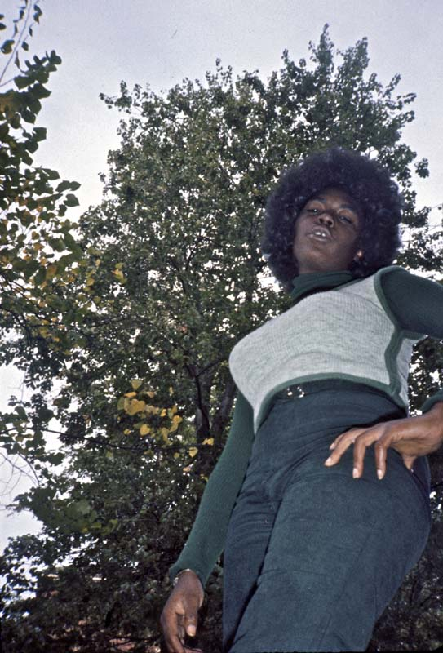
Tony was so impressed that the next day while Mack was at work he took the day off to pick me up and take me to lunch at the finest "black bourgoisi" restaurant in town. Here he confessed that he had never met a white person before with whom he felt he resonated so much, and so suggested that I move in with him "so we can inspire each other." I felt the same way about him, but suspected he was inviting me solely to make rival Mack jealous. And precisely to avoid hurting Mack's feelings and pride, I then had the idea to move in with Geegurtha first until I knew Mack was going on vacation. No one, like the male chauvinists Mack and Tony, would understand why I preferred a woman to them. It was a strong principle I had about respecting people's hospitality, never - especially in my relationships with women - hurting their feelings by moving in with other women in the same town.
By staying with Geegurtha for almost a week, I was now also able to convince Tony that I was truly dedicated to the cause and not interested in cheap sex. Because just as Tony and the other counsellors would be fired for having sex with their clients, I had already told Tony that I had never had sex with a prostitute and was totally against it, as I didn't think they could distinguish this from their profession. Instead, I always tried to relate to people's deeper humanity - even though this might be buried and distorted under their immediate 'patterns of suffering' - a term which, incidentally, Tony later taught me to use - autodidacts that we both were. Only in this way, I believed, could a relationship develop with mutual freedom and equality for both parties.
Geegurtha now told me that it was precisely this side of me she had been able to see during my captivating lecture at the clinic that had given her the courage to invite me home. And so she now insisted that I share her double bed in the house at 817 Waugh St, where she lived with her extremely devout Christian sisters, as if it were the most natural thing for us to do. It surprised me, but I found out that she saw this as part of her rehabilitation slowly along with a man she trusted to rebuild a natural relationship with men after the years of exploitation by them. I had only had a few serious black girlfriend relationships at the time, so with my previous leftist over-romanticization of black women, I also felt that my play and intimacy with Geegurtha was part of my own rehabilitation to achieve a more natural and equal relationship with black women. In other words, we needed each other, the black whore and the white knight, as each other's saviors. Naked, we caressed each other in a wonderful loving intimacy, but although I felt tremendously attracted to her, I noticed that it was never a sexual attraction, as it often is in my relationships with lesbians. We shared bathtubs and tossed pillows around naked, and Gee said she had never experienced such wonderful, relaxed intimacy. She hadn't been able to develop loving intimacy in the destructive relationships she'd had with her clients in the past, if only because as a drug addict she'd only been thinking about her next fix. I loved her jet-black skin and large breasts, covering them with the contrasting white foam as we bathed and frolicked together in the tub - images that therefore later meant a great deal to me, but which I later had to remove from my slideshow in America, where people saw black skin with racial discomfort and the images as sexism - even though they were the result of the exact opposite, the joy of sudden freedom from sexual exploitation.
Sometimes we sat and jerked each other and had spontaneous crying sessions where it felt like all the pain came out. This wasn't something I'd tried before, but I think she'd learned a bit from the therapeutic conversation circles in the drug program she was in, which used roughly the same methods as AA meetings. In that way, I felt I had a lot to learn from her - including about my own repression as an emotional knucklehead.
When Gee went to work at the Drug Action Council in the morning, her most conservative church-going sister, Georgia, picked me up for lunch at the YMCA where she worked and told me how they enjoyed seeing Gee loosen up so much and even be able to spend time with a man again for the first time. Just the thought of a man had repulsed Gee after her many years as a prostitute and drug addict. For five years she had not seen her daughter Tania, who was born a heroin addict but rescued through blood transfusions and raised by her sisters and grandparents like so many other black children in the same situation. I was moved to tears now seeing and photographing the strong maternal love between Gee and Tania after their long separation.

While her Christian sisters appreciated and even loved me for my important role in her long healing process, the brother certainly did not. When he came to visit one night and found us sleeping together in the same bed, he perceived it as sexual and immediately called home to protest to their parents. They came rushing over and scolded us right after church on Sunday morning with such a blatant racket that I was just about to pick up my tape recorder to record the biggest bitch fit I had ever had for violating the ghetto's social controls. Gee couldn't take them seriously either, her mother having just kicked out their hopeless father herself and now coming presumptuously with her enormous church hat and her new outrageously small and ridiculous husband, who in no way exuded any sort of authority she demanded of him in the situation. So we just lay in bed laughing our heads off at all their shrill shouting about how "it's not decent for blacks and whites to sleep together".
Another day I took Gee hitchhiking, but it turned out to be a bad idea as it brought flashbacks back to all the years she had stood and flagged down white motorists to lean in through their windows. But also because the sight of a white man with a black woman appeals precisely to the baser instincts of drivers, who reflexively see the black woman as a sex object. That the freedom of the white vagabond does not necessarily equal the freedom of the black woman, I would later experience numerous times when hitchhiking with black women.

By then, it was about time for "homecoming," when most black students in the North come home each year to visit their families in the South and vice versa. I had been helping Gee all day cook a huge pot of chitterlings out of the stack of comas stinking up the utility room, gradually turning the whole thing into a nasty little slimy mass so foul-smelling the whole town could smell it. Chitterlings are the one Southern "soul food" I absolutely cannot get down (at least not with pleasure, though sometimes with my nose closed to avoid hurting people's feelings). It was wonderful to party for days with all the happy family members who came home to brag about how well they were doing up north, and I couldn't escape the thought that Geegurtha, too, in her years as a drug addict up in Buffalo, might have come home bragging about how well she was doing. But why can't blacks celebrate with a little more liberation rather than on feast days keeping up the traditions of "the good old days"-that is, going back to the inedible parts of the meat that whites under slavery fed the slaves because they didn't want to eat them themselves. Do you really have to suffer so much to demonstrate that you are against whites? To me, it would be equivalent to "walking in the flesh" of a woman who is analogously trying to free herself from the bondage of prostitution. And I certainly lost all desire to do so when Geegurtha, in order to provoke me, stood with the spatula and with the greatest relish and self-irony - as if she were licking the semen off a man - stood and licked this foul-smelling blubber into her - and then tried via the mouth method to force it into me. "Now you're getting too sexual! I think it's time to say goodbye to you," I laughed. And in this she agreed, for with so many relatives in the house back home from the free-spirited north, they might think that in the company of a white man she had become a fallen and loose woman.

While Mack had gone home to home coming in Washington DC. I had picked up my backpack at his house and moved in with Geegurtha with the intention of eventually ending up with Tony. So a week after meeting my new friend Tony, I was finally able to move in with him on October 13 and start our long friendship, where at the time of writing today I just congratulated him on Facebook on his 68th birthday. (I have a wistful picture of me standing with my backpack and my hitchhiking sign with all of Gee's family outside their house at the farewell).
I had visited with Gee, a grandmother who was caring for her 2-year-old grandson (page 135 of the book). This child I found out was also born an addict in her mother's absence while she was active as a prostitute. Five years later, as I sat showing Tony's friends in town my newly published book, Mike Akins stared at this picture and said in amazement, "That's my son in that picture."
And that's how I discovered the truth about many of the other runaway drug addicts and their neglected children, a problem that has sadly only gotten worse since then, with one in ten black children today growing up without parents.
But sadly, I also discovered the truth about Geegurtha every time I returned to visit her over the years. Her sisters were happy to see me again but didn't know where Gee was. Sometimes, though, I had the feeling that they knew what had happened to her but wanted to spare my feelings by not telling. Of course, I could figure out that like so many other former drug users, she had fallen back on the heroin. It wasn't until 2003 that I managed to find her in Atlanta, where she again invited me to move in. She was now working at Works Grady Memorial Hospital and living nicely but wouldn't go into what she had been doing through the 80s. However, she had never lived with a man again after we lived together in 1973. Since Tony had now moved to Atlanta after our many years in universities, I invited him to Geegurtha's home one day and we chatted pleasantly about "the good old days" - now that we were all on the good side of 50.
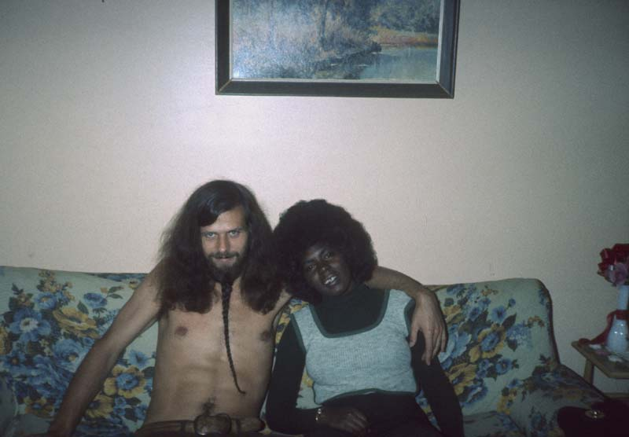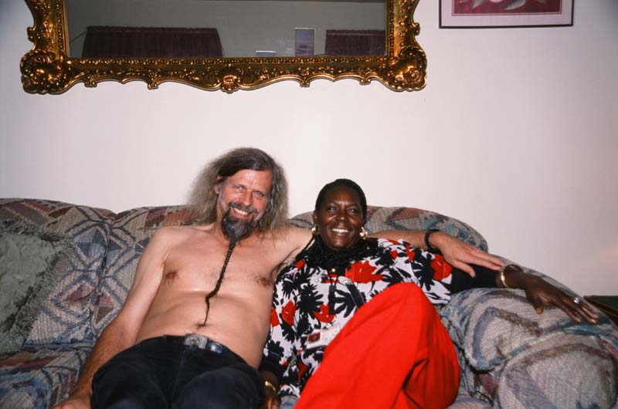
With Geegurtha 1973 .......and 30 years later in 2003

Since Gee's sisters had amused themselves by taking pictures of me half-naked with Gee, I got Tony to take a similar one of us together - 30 years later - both now considerably less hairy.
When I brought my film crew around in 2015 to make the theatrical film about my life with my friends, I thought in Atlanta to include Geegurtha in the film. But Tony now told me she was dead. "Of what?" I asked. "Of AIDS," he sighed.
If true, much evidence suggests she contracted it as an injection drug addict in the '80s, when an incredible number of my black friends contracted HIV.

Although Gee ended her life as a hospital worker, she had apparently relapsed after her first rehabilitation attempt at the Drug Action Council in 1973. I have since wondered if I did something wrong in our private play therapy - too short-lived and unprofessional as it was to be of any long-term use. But actually I think we were on to something in our wonderful play with each other. When I moved in with Tony, I learned a lot about the psychology of prisoners and how he tried to help them himself - including having to move out of the living room after a while because a guy on parole after years of prison wanted my room. But even for Tony, with his years of experience, the real shift came when, a few years after our university tours started, he came across and was inspired by a particular form of "reevaluation co-counseling" and said to me, "Jacob, get into it, because the theory behind RC puts into precise words the way you've always thought in American Images. And how closely these methods turned out to resemble the way Geegurtha and I had "counseled" each other through shaking, laughing and crying, I experienced when in 1988, after a long period of seclusion, I attended a "men's liberation workshop" in Seattle and - at first deeply skeptical of the methods - had my accumulated bundles of pain released in the form of crying and laughing. After three days of rolling around on the floor with CEOs and paupers, fat and thin, young and old, white, black and brown, I felt a true liberation and redemption, and something strange happened. Whereas in the past - even as a popular lecturer - I had found it difficult to connect with people, it was as if women in particular now felt drawn to me (read about the end result in "On Saying Yes to Women").
Exactly the same thing happened now in the time after my relationship with Geegurtha in 1973, that while in the years before I had felt, as I said, that prostitutes almost avoided me, it was as if they now everywhere felt drawn towards me. In other words, by "integrating" - in the strongest sense of the word - with a prostitute, I now found myself in one relationship with prostitutes after another. Today, the prison system in the United States in particular has begun to use exactly these methods, because no matter what was tried in the past, as in Tony's, Mack's and Geegurtha's Drug Action Council, released prisoners continued to have an average recidivism rate of 65%. But for all the prisoners who have been through an RC-inspired recovery program like the Inside Circle Foundation, the recidivism rate so far has been zero. So if I had not failed, but had continued my playful "discharging" sessions with Geegurtha, she might not have later died of AIDS.
Yes, well, she could have just left off in her diabolical obsession to "discharge" smelly, slimy green chitterlings into the head of the exorcist. 😊

Many professional psychologists and therapists can probably individually achieve the same good results, but the advantage of the method I learned, so to speak, in bed from a prostitute in distress, is that it is free and equal in that the two involved constantly change roles as therapists and clients towards each other, which is why it is equally useful in the relationship between black and white racist, as sexist, homophobic, Islamist suffering patterns - between oppressed and oppressor. One quickly realizes that we are all equally oppressed in such misanthropic systems. Above all, it benefits society as a whole since participants in the close sessions cannot help but develop genuine empathy towards each other - an empathy that brings more empathy and positive curiosity towards everyone else - thereby helping to gradually liberate everyone else.
It was this last I experienced now - especially in relationships with prostitutes and drug addicts. And it was to benefit Tony's family. Because while I was living with him, I started hanging out at his father's bar, "The Grill," which was the ghetto's most violent drinking den and hangout for criminals and prostitutes. Whether this was because the blacks knew I was friends with Tony's father behind the bar - and perhaps in that way I could get them drinks or keep them from being thrown out during fights - or whether it was the knots Geegurtha had just untied in my mind, only the Lord knows for sure. In any case, the result was that I was now the object of wonderful interest from the prostitutes, whom I came to know well and often ended up going home with. One of them was Dorothy and her friend and we decided that I should go with them. First we stole some wine in a shop and then dashed straight out in the waiting taxi. Once we were in the back seat and got going, I asked the girls how they intended to pay, since I knew they had no money. Never mind, they said, just wait. Let's sort it out. When we get to the place, we'll just knock him out and take all his money. This came as a bit of a surprise to me, as I had never tried to beat up a taxi driver before, but I didn't say anything anyway.
Then suddenly the black driver turned around to ask me something and I realized I knew him. After all, it was Tony's grandfather who owned the biggest black cab company in town. So maybe I took matters into my own hands. I shouted at the driver to stop, and told him he could get paid the next day through Tony. Then I yanked the handbag with the gun out of one girl's hand and pushed them out the door, while they gawked as much as the cab driver. Out in the street I shouted at them: "That's Tony's grandfather, you fools". Although they knew Tony, this fact would not have stopped them, of course, but once they were out of the car and the taxi had left, they had no chance of hurting him.
It's kind of funny that when I told Tony the story a few days later, he didn't react to it, so hardened had he become by the violence around him. Only when he read it in my book in Denmark 4 years later - and saw it all with Danish eyes - was he shocked and thanked me for saving the grandfather, whose funeral he had to go home to from Denmark shortly after. There he was shocked by all the old ladies who had turned up for the funeral, "I had no idea my grandfather had SO many outside girlfriends as a taxi driver."
However, my book's description - based on a letter I had written to a "nice" American family - did not include all the violence and sex I experienced later that night after rescuing Tony's grandfather, after which I, along with the two girls, had to use the apostles' horses. The rest of the story I had long forgotten, but recently found in my diary:

Wednesday, November 28 - Greensboro
In the evening at the grill where I met two pulling girls, Dorothy and another. We left and saw a cab from Tony's grandfather's cab company pull up outside. Got in, but they didn't have any money. Took the gun up and said they'd get themselves a free ride. Knocked the gun out of my hand. We then went down to cheap hooker bar after one stole some food from a store. Spent all evening the other place between really broken down prostitutes. I backed man with shotgun into door. Took cab with Dorothy and her client to his home. But she wouldn't stay there afterwards. So it was late before I was invited home with her for morning pizza.
This was one of the first times I more or less unwittingly found myself in the role of protective pimp. I did this with great pleasure, because time and again I saw how these miserable drug addicts were mistreated by their often extremely violent and drunken customers. They really risked life and limb in more ways than one just to get a few dollars for some heroin. So I wasn't ashamed to get my payment off - well, in this case some morning pizza before we passed out after the night's debauchery. But the day after we could often have some good conversations along the lines of those I'd had with Geegurtha, although staying with active prostitutes was a bit more challenging.

Often the rawness of these women shocked and surprised me. I constantly saw them doing the vilest things to both men and women. That is why it was such an overwhelming experience when an intimate relationship could develop between us, and I had the opportunity to glimpse the warm humanity beneath the hard shell of evil and backstabbing that this violent system had given them. People who are so enslaved by a violent way of relating have a deep longing for freedom and a more humane way of relating to each other. Yet I saw everywhere how this longing could not flourish, as it was constantly stifled by the violent vibrations it received from the ghetto's other prisoners. The white and better-off blacks with "fine culture" did not come into contact with this longing, as these "fine cultures" had only contempt for the ghetto culture - a contempt that was constantly felt and sensed in the ghetto, and which was the direct cause of the ghetto becoming more and more violent. The tenderness I so often found in our relationships, which could so easily have been allowed to take root in more humane social systems, seemed so unspeakably powerful and painful to me precisely because I saw over and over again how the parallel communities we choose to build on a foundation of not engaging personally with our neighbors made it more natural for these girls to act in a pattern of cruelty rather than tenderness.

6. On my escape from world-renowned artist to artistic call girl

That human trafficking thrives just as well among those of us who choose to live in "fine cultures" I saw at the other end of the spectrum. And even in those strata, I was frequently rescued by prostitutes who could conveniently use me as a pimp. My funniest experience was in New York, where a mysterious woman had felt attracted to my fish eyes and invited me home to stay. She lived in a huge apartment on Greene Street and had a studio on Broadway as big as a handball court. Her bathtub was a small palette-shaped swimming pool. The only thing she wanted from me was to be with her. For three days we sat from morning till night staring into each other's eyes. There were huge plaster fish everywhere; they hung on the walls and stared stupidly down at us. But there was definitely more life in them than there was in her. For three days I tried desperately to talk to her. All I got out of her was that she felt very lonely and that she had never lived with a man. She was 40 years old, born in the sea and could only communicate with fish. She had nothing else to say. I was curious to know who she was, so one night, while she was sleeping, I rummaged through her papers and found out that she was the world-famous artist Marisol Escobar and had twice been on the cover of Time magazine and once on Look; but her last big exhibition of fish sculptures had received bad reviews. It turned out she was swimming in money. Once I had to sign as a witness on contracts worth thousands of dollars. She spent half the year in the Gulf of Mexico diving for her little friends. Nevertheless, she never gave me so much as a loaf of bread, and I grew more and more desperate with hunger. Morning and evening I would accompany her to restaurants and sit across from her while she ate. She was immensely self-absorbed, not thinking of feeding me at all. Since I never ask people for food myself, one day I made an indirect suggestion. "Have you ever thought that all your art goes to the rich but does not benefit the poor at all?" No answer. And still no food. She had a refrigerator, so when she was asleep at one point, I took the liberty of checking to see if there was food in it. I had a minor shock when it poured out large frozen fish that looked like cod - and nothing else. If I hadn't been so hungry, I probably would have had a little more patience with her.
Marisol sat like that from morning till night, staring at my "fish eyes"
Then suddenly my rescuer came wandering into the silence. It was Erica, who had earlier helped Marisol polish the fish sculptures. She laughed and was happy, and it was great to hear a human being again. She quickly perceived my situation and as elegantly as a fish, let seven dollars slip into my hands under the table. Later she whispered to me that I could move over to her. When Marisol fell asleep that night, I fled to Erica's, who lived in a squalid fire escape on 11th Street. Erica was simply a find to live with. She was a lesbian but did not harbor the hateful feelings toward men that I felt (at the time) characterized most lesbians. So it always made me happy when I got into a good relationship with a lesbian girl.
Like me, Erica couldn't understand the need to hate men. Erica was a different girl. She immediately made me the male chauvinist of all time since my function in her home was to be her pimp. Erica was a prostitute of the fine type known as a call-girl, and it had now become my job to be a telephone attendant, sorting out the naughty calls and asking the nice ones to call again at 5pm for a quick second sorting. Then the final rush began at 6pm, when I had to choose the very nicest voice and arrange to meet at a hotel at 7pm. We then took a taxi to the hotel, which was usually on the east side as we stuck to nice business people. Here it was now my job to sit and drink Coke in the foyer for an hour, and if she had not come down by then, I was to go up and knock on the door. On the way home we usually went for Italian ice cream, which Erica loved.
But the amazing thing about her was that she was no ordinary whore. She had an ad in the sex magazine Screw, which apparently all businessmen read, because the phone rang incessantly. She simply loved to help people and to give them warmth in the middle of this cold. She told me that most of her clients were extremely lonely and didn't need sex as much as they needed warmth. Indeed, seen through such men's eyes, she was no physical beauty: enormously thin, flat-chested and with curly red hair, but she had such charm and beauty about her that these men couldn't stand her at all. Almost all gave her $100, though we had only agreed on $75, and only one called to complain. She said she usually didn't even sleep with them, but just gave them physical and especially spiritual massages. She bought me many movies to support my project, but I said no to money for good reasons. During the day she would go to singing and dancing or sit for hours making coffee sets out of foam rubber. Every cup, plate and spoon was made perfect to the last detail. She had several glass cabinets full of foam porcelain like in the nicest bourgeois homes. She was a great inspiration to me. One day, when a man was knocked down outside in the street and left lying there for a long time, Erica was the only one who bothered to call an ambulance. But no ambulance came, and people just stared stupidly at the half-dead man. She kept calling. Because only Puerto Ricans lived here, it usually took an hour for the police and ambulance to arrive. Then she had the bright idea to call the police and tell them to hurry up, because there was a white man being attacked by three black and Puerto Rican men right down the street, and immediately two police cars and an ambulance came. This trick was common in New York, but it apparently worked every time. Often I saw Erica giving a whole day's pay to people in need. She took them straight from the rich businessmen in the hotels to some beggar on the street.
Another night she was even more amazing. We were on our way to the cinema when we saw a bum in his fifties sitting and asking for help with a bottle of wine and someone to talk to. We sat and talked to him for a couple of hours over the wine and he said he was having delirium tremens and that he was afraid of dying. Immediately Erica said we would go with him to the hospital and he cried with joy. He had been waiting for this moment for ten years. He had never had the courage to go to the hospital himself. We took him in a taxi and drove to St. Vincent's Hospital. We sat in the waiting room for two hours. The whole time he was crying. Then we were told they wouldn't take him. He had been drinking and became completely impossible and started shouting and screaming. I also shouted some things at the staff about coming from a civilized country with free hospitals for everyone. The police were called and we were thrown out with the music blaring. We then took a taxi to the emergency room at Bellevue Hospital and sat there with the strangest people: screaming, hysterical, suicidal, and whatnot. We sat there until 6 o'clock in the morning and nothing happened. Meanwhile, the man drank the whole bottle and sat on the floor crying with his head in Erica's lap, begging us not to leave him. Several times he peed in his pants and there was a lake outside when he took out his penis and left it hanging. Erica kept tucking it in, but it kept coming out. Most of the patients had eventually fled the room. Then he started vomiting all over the place, the weirdest slimy and smelly vomit I've seen in a long time. At that point, even the two nurses fled. We tried to wipe it up. By 6 we were exhausted, and when the nurses promised loud and clear that he would be admitted, we went home to sleep. Two days later I went to Bellevue Hospital to see him and give him some cigarettes. I was told that no one of that name had ever been admitted. I was furious and unhappy and didn't dare tell Erica. New York is a city that simply does not allow any human being to be human. If you want to survive here, you have to learn to let other people down. Erica, of course, was not from New York, but from the Midwest.
I followed Erica over the years. When I wanted to include her story in my book, she approved my explanation, but asked me to change her name to Erica for the sake of her "sheltered middle-class Midwestern parents" who couldn't know she was a prostitute. This role was merely her temporary way of raising money for the finest music, singing and theatre schools, through which she has in the years since made a fine career as an actress. And right near the beforementioned Bellevue hospital, she now teaches children with cancer at the Hassenfeld Children's Center with her husband, an actor from Thailand. Her compulsion to create foam rubber characters 45 years ago has also evolved artistically, as she now works as a costume designer, creating giant rainforest figures and fantasy animals for museums across America. I have a picture of President Clinton standing with one of her animal figurines, for example. And just as she had a loving healing effect on the people she helped back then as a prostitute, critics say the same about her today: "She touches her audiences in ways most of them have never been touched before in a performance setting. What Erica does is always entertaining, but it's much more than that: it's a kind of healing art. "
Thus I have no doubt Erica ended up touching people far more than the sophisticated world artist Marisol Escobar, who died in 2016 at 85 just after my last visit to New York. Two years after Marisol, I stayed with a black artist, Al Loving, in New York who had taught her and told me how during it all she had just stood with her back to the class and stared into the blackboard. Marisol was deeply traumatized after her mother committed suicide when she was 11. In her teenage years, she wandered around on her knees until they bled, and didn't speak up for long periods either. But both she and Erica were inspiring in showing that you can turn something painful into art.
President Clinton with one of Erica's characters and herself
More pictures of Erica Hickman today
7. On my failure by Martha the streetwalker in Harlem

And I did it myself with another prostitute I stayed with in New York, using my friendship with her to be called an "artist" at Louisiana. She was an old prostitute friend of mine who I had been able to keep in touch with over the years simply because she kept living in the same place while everything was falling apart around her ears. But probably even more because in Harlem I always needed a place to stay - especially after the relationship with my old lesbian girlfriend Sapphire just around the corner had to be put on hold for many years (see in "On saying yes to lesbians").
I met Martha at a wedding in the apartment next door to hers of my friends Robert and Celia. It was a romantic wedding where we all wished the best for the two young lovers - not least the lovely bride. But in the years that followed, Celia got on crack, their relationship broke up, and to get money for the drugs, Celia started hitting the streets as a drug addict, while Robert, in all the 45 years I've known him, has been a "good church-going man" who has never used drugs. Today Celia is dead from addiction.
When Martha was a neighbor at their wedding, I noticed her flamboyant and flirtatious dancing and acting. She clearly liked me as the only white person in the party and made no secret of it, but Lela and the rest of my friends whispered to me that she was, well, just a "merry girl" - which only made myself happier. Since I still had little fear of going home at night in Harlem during those years - if I even knew where "my home" was that night - I was not hard to persuade to end up in her all-embracing loving bed in the next apartment. And so, once again, a prostitute saved me.
But there was such a crush on her during those years that I could rarely psychologically bear to live there for any length of time - albeit it was one of the largest apartments in Harlem - so cluttered and with stored furniture that there was often only room in the large bed she used for her clients. We had many good conversations at times about her and my contemporary life on the streets as streetwalkers and street vagrants, but in her exhilarated narcissism and obvious escape from a deeper pain, I never felt I got to the core and generally gave up. Most uncomfortable with my betrayal was when she always tried to turn my interest to getting my help in getting her son Sam out of prison "upstate" New York where she could rarely afford to visit him. Even in the years when I, a busy lecturer, had a car, I didn't take the time to drive her all the way up to Attica prison. At the time, I had so many friends in prison that I couldn't face taking on more cases involving people I didn't know personally. I always had a hard time when blacks -already by virtue of being white- clung to me with such desperate hopes that I knew only the most expensive lawyers could fulfill. Moreover, she represented my usual dilemma with prostitutes; some of them seemed like free determined women who had chosen their profession for themselves and others seemed like real victims who had been forced into it by oppression. The latter needed compassionate help, while the former, like Erica herself, felt uplifted by helping others. Most were probably on some sliding scale in between the two extremes, such as Martha, who one moment had great compassion and the next made me feel like I should be helping her - especially in the later years when my (white) power was growing and her (black) powerlessness was also growing. For the same reason, like other feminists, I have always found it difficult to take a clear stand on the subject of prostitution, preferring simply to love as best I can the people involved as they appear at the moment - with the damned obligations that sometimes go with trying to love.

My mentioning Martha here at all, rather than so many other prostitutes with whom I have since lost touch, is due to my later history with her.
When I had my exhibition at the Louisiana Museum in 2009, the curator also wanted to include some of my more recent photos - especially of my old friends today - and sent me all over the United States. So after a few years' absence, one Sunday after church in Harlem I got to wondering if Martha and other old friends still lived in the neighborhood, now that I'd stopped my annual US tours. Harlem, after all, had undergone a huge economic boost since my vagabond years, so many of my poor black friends had been forced into New Jersey's hideous ghettos by high rents. Several other friends like Robert Yard in the same building had moved, and from almost every door I knocked on, white newcomers were now coming out. So I was anxious when I knocked on Martha's door, but relieved after a long wait to hear her all-pervasive cry of joy from inside, "Jaaaacoooob!"
I was ashamed when I realized I had last stayed with her during my university tours in the 1980s, back when she was still hot as a merry-maiden and I took this photo of Martha in her red party dress, which I loved because she always wore it when we partied together.
So it was a bit disheartening to see her now as overweight and toothless and barely able to walk. But she insisted on partying with me again immediately, "let's party like in the old days," and I took pictures of her putting on her gray-haired wig in the messy room that was supposed to be a living room and where I usually pushed things around to sleep when I was at weddings and parties in Harlem and she had clients over. Although she had come home late the night before on this Sunday afternoon, she insisted on dressing in her usual party dresses with gold chains around her neck the way I remembered her from the old days.
As it was stiflingly hot, I invited her for a walk to the local park. It was then that I found out that, as an old worn-out hooker, she could now only roll around with the aid of a walking frame on wheels. Still, she said as she used to: "It's a bad neighborhood, but I'll protect you!" I was a little amused to be "protected" in Harlem by an old toothless woman on a rolling tripod, but as you can see from my other photos of local gang members from that day, they all had a deep respect for her. She stopped to talk to everyone, so I was amazed at how many new friends I made in no time.
It was particularly depressing to see Martha's local "green" park - a sterile concrete area surrounded by traffic and noise on all sides, where she usually went to relax and knit.
On her way back she got tired and I offered to push her in her wheelchair. But when we hit a bump on the sidewalk, she fell over backwards and slammed her head backwards into the pavement with me on top of her for so long I was in the classic missionary position. This was in front of a crowd of people who knew her profession, so we got a lot of funny sexual comments.
We bought beer at her local store, which like every other store in Harlem today is owned by Arabs. They have taken over the old Jewish shops that I remembered from my youth. The beer was good for loosening up her first customer later in the day - Ron, an old regular who had become a semi-boyfriend.
My little photo story in Louisiana ended with them in bed together in the messiest bedroom I'd seen in years, so messy that it was only half the bed she could use for business as usual. The other half occupied, among other things, her many cell phones, her contact with the outside world, which most of her time in bed all day long was spent looking for when clients called less and less frequently.
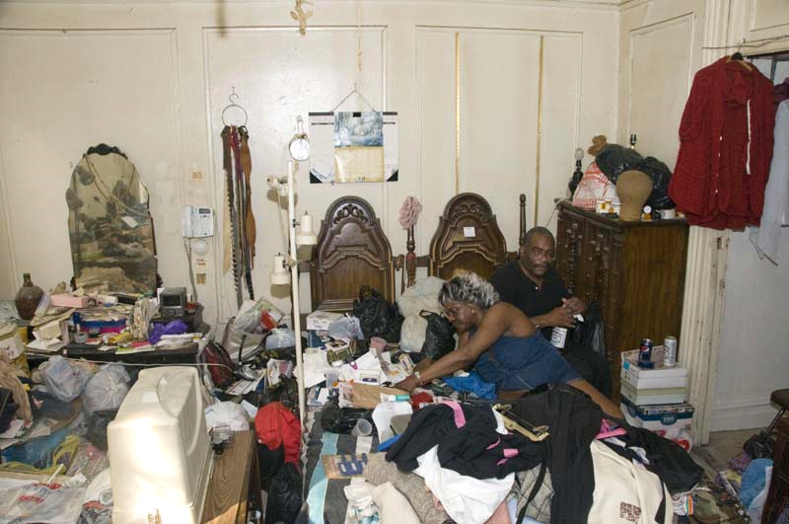
Yes, it was nice to see at least one old prostitute friend who had survived the hard life, but not exactly exhilarating to use her in giant size in one of Louisiana's largest spaces to prostitute myself with as an artist - or con-artist as many blacks would have called it.
Later I visited her again with Søren Pind, whom I had not warned about her mess and foul odor, and who got such a shock just stepping into the hallway that he refused to step any further into her misery. I did manage to make a little video clip of these two opposites, but again, as before, I felt I was prostituting myself by dragging film crews along with me to the homes of my old vulnerable friends, whose situation has only gotten worse with the years .....while my own has gotten better and better at their expense. It was not the Christian Søren Pind who betrayed me by refusing to participate in my dance of death with her - where I betrayed her now for the third time:

No honour, no glory,
no such perfection
can there be under the sun,
that it is assured by
...against sinning.
No office, no calling
is so sacred that it cannot
can yet have a sin-prick

He denied you thrice
and forsakes the God of his heart.
My falls are so many
Against every word and commandment of the Law,
that they may overflow
the number of the stars and the waters of the sea;
mouth and tongue, heart, eye
bend from thee to the world.

Matt 26,69-75. The story of suffering. Section 7.
Thomas Kingo 1689.

9 pages with my pictures of my life with Martha

8. On my own fall and defeat in the meat ghetto

The feeling of letting people down by photographing and exhibiting them rather than helping them was something I already felt increasingly during the vagabond years, and indeed complained about in many places in the final superficial result, American Pictures. So instead of buzzing around like a fly registering the pain, I decided toward the end, when I married Annie, to settle down and actively work for groups that were doing something about the problems. In doing so, I in turn abandoned my black wife, who after 10 years of luxurious alienation was not at all prepared to live in the ghetto and went completely mental.
We moved into the top of the 5th floor of a slum full of mostly drug addicts, alcoholics, transvestites and other scum. I felt like I was in heaven at first, because the more my own marriage fell apart and Annie broke down from drinking, the more I ended up hanging out on the streets like the ghetto's black men. It was a chaotic time trying to work simultaneously with prisoners, criminals, prostitutes, drug addicts, homosexuals, and transgendered people all at once. This was partly possible as many of them belonged to the Glide Church, which we lived next door to and in which I volunteered partly by feeding the poor and homeless and partly as an international spokesperson to the international media. As I also tried to photograph the different people I met in my work - and thus put myself a bit at a distance as an observer - it goes without saying that I was not always equally effective in my work with the groups. It didn't always matter, as most of the people we tried to organize, for example in unions for prisoners or prostitutes, lived even more chaotic lives than I did. And unlike some of the white upper-class onions who came from the suburbs and helped move paper piles in offices during the day and then went home, I stayed on the streets at night, as I said, where I had the opportunity to achieve a more human relationship with those whose lives we were trying to help.
In particular, I got to know all the prostitutes in my own building at 340 Eddy St in the Tenderloin ghetto, when they made themselves - as the name suggests - into delicious "tenderloin" on the street outside and when I was invited to parties and house parties in their small one-bedroom apartments. If I wasn't kept awake indoors by my wife's drunken weeping and wailing, I was constantly awakened by fights often with the pimps in the adjoining flats, to which we had open windows over a meter-wide deep shaft. The neighborhood was said to have been named precisely for "the soft underbelly" traded here, while some police officers boasted that because of all the bribes they received here, the Tenderloin was the only district in town where they could make enough money to eat tenderloin every day. Other cops, like the pimps, justified this as "hazard pay" for working in such a violent area, both of them making heavy use of their "sticks" to bring up the income.
I slipped so naturally into the community that the pimps didn't even mind my photography while they beat their "hoes". Only a few times in the beginning did I try to intervene between the pimps and their "hoes", whom they beat to pieces, but gradually I myself became brainwashed into the violence and just tried to record it without emotion. I often witnessed the pimps' "gun whipping" of the prostitutes, but with my 160 ASA film I didn't dare use the flash to photograph it for fear that in the heat of the battle they would suddenly use the guns on me. Sometimes later I sat with the crying and bleeding victims in an attempt to comfort them, but soon I became as numb and numb as they. There was violence and screaming and excruciating pain in the building day and night as well as fires set almost every other night where we were all awakened by the fire alarms and had to rush down to the street in our nightclothes with our most important belongings. I remember how we all just repeated the words "I gotta survive" in this richest country in the world no matter if we had to literally trample on the others to save our skins.

But the most impressive thing to me were the prostitute drug transvestites. Some I saw injecting so much heroin that you couldn't tell their bruises from violence from those from needle sticks. One white drug-prostituted trans in my hallway I spent a lot of time with, as she felt she would soon die from abusing her body so much and asked me to photograph her naked in all her stigma. One Latina among them I met on the street one night and thought for a long time it was a woman as she tried to achieve sex with me offhand, and in my effete state at the time it must have gone quite far, for I remember my astonishment when I discovered it was a transvestite, though I had heightened senses in that direction from living with so many of the kind. I think that was the only reason I took a picture of this beautiful Latino "woman" because she took me off guard and not the other way around. Hardly a night went by without me seeing police violence against them and the other prostitutes. The walls of our upstairs were often smeared with blood.
While I had lived a free life on the road as a vagabond, only occasionally immersing myself in human pain without really being affected by it, now in my hopeless marriage I felt without escape for the first time.

Annie had lived for ten years on a luxury yacht in England with a boyfriend and had not lived in ghetto culture since childhood. So it was a terrible shock for her to end up here shortly after returning "home" to the US following the murder of her mother and stepfather. Because of her good looks, she was constantly harassed by pimps and hustlers who tried to recruit her. One day, a pimp mockingly threw a handful of money at Annie on the bus. In my old vagabond habit, I picked it up. Annie was furious with me and wouldn't speak to me for a week. She tried to get me to write a book about my experiences on the road, but it was impossible for me to write in those surroundings. I did get a little writing done during the day when she was at work, but when I reread it recently, I had to give up in the discomfort of being reminded of the most self-indulgent and useless thing I ever wrote.
It was during this period that I began to develop my theory of the ghetto as a closed system that crushed all people and caused them to escape into self-destructive escapes rather than focus on education and intellectual development. For it was exactly this downward spiral that I myself had first fallen into, where I also clearly began to see myself as both an executioner and a victim of society's racism and sexism. And especially seeing the unfree survival relationship between black pimps and prostitutes at such close quarters prompted reflection on my own trafficking-unfree relationship with Annie, whom I had married solely to obtain work authorization and permanent residency in the U.S. while she, in turn, wanted my help in fleeing back to Europe. During the long 10-month wait for the green freedom card, we were forced to live together in this closed system in nervous uncertainty as to whether we would even be approved. I will write more about my relationship with Annie in "On Saying Yes to Black Women", only noting here that my identification with the surrounding violent master-slave relationship between pimps and prostitutes on the one hand helped us both to keep our heads above water by feeling better than them. Annie, for example, was the only one in the building's 85 apartments who had a regular job. On the other hand, it was so debilitating for both of us that we ended up in the same escape attempts as the ghetto's other prisoners, Annie in the form of all-night drinking and me in either escaping onto the streets or in short-term jaunts out of the ghetto.
It was during an excursion with one of the prostitutes, Margo St. James, to her astonishingly luxurious surroundings in the upper-class neighborhoods of Marin County north of San Francisco that she helped me see what a devastating closed system I had found myself in the middle of. And conversely, that when such relationships are seen between people, it reveals that they are not free, as such relationships can only exist in a closed system. In the lower class, such slavery was seen most clearly in the relationship between trafficker and prostitute, Margo said. The black prostitute was totally subjugated by the pimp and groveled psychically at his feet in deep anguish. The pimp, for his part, was not only an executioner but also a victim in the larger system in which he was the new slave keeper, charged with seeing that the "goods" were delivered to the slave master - the white man. His weapon today was simply not the whip, but "the pimp sticks" made of recycled steel hoops. Although the pimps, like businessmen in the outside world, could behave quite inhumanely, it was important to remember that they, like them, were acting according to very definite rules and laws over which they had no control. These laws were laid down in "The Book", an unwritten business manual that had been passed down from pimp to pimp for generations, and which described the subsystem of this larger economic system. Woe to the pimp who didn't follow the rules! Like the larger capitalists, they had their daily board meetings, where they not only discussed how to keep wages down, but also exchanged technical details regarding the subjugation of the "ho's" (prostitutes). Similarly, they fixed their girls' working hours, what they called "git-down-time." One could usually tell which girls belonged to a "mack man" (pimp) and which were "outlaws," since all the organized ones came on the street at almost exactly the same time each night, while the self-styled "outlaws" came and went as they pleased.
The reason why we had got on so well with each other in the past, too, was no doubt that the prostitutes, as "outlaws," had to know the "system" of the underghetto in every detail in order to keep free of pimps, while I, as an "outlaw" (vagabond) in the larger society, had acquired a certain knowledge of it afterwards in order to survive in it. We had therefore come to a common point of view in very different ways. Since the parallel between the superstructure and the substructure was so clear, it was usually easy for them to see the inner dynamics of the overall system that was responsible for their double oppression: racism and sexism.
For the relationship between pimp and prostitute was in many ways simply a highly exaggerated model of the relationship between man and woman in the lower ghetto (or even in American class society as a whole). Here, one of the man's many "hustles" consisted of obtaining "broad money" from defenseless women in exchange for protection from being "hit on" by other men's sexual aggressions. In such a society, women horrifyingly see men as, at best, merely a means of obtaining money and luxury. She is often quite forthright and blunt about her desire to marry a rich man. This quick ghetto flight to wealth and security often shocked me, as it was something I had rarely encountered in Danish women - probably because such exploitation between the sexes does not make the same sense in a welfare state with more economic equality. The prostitution that consists of buying women with status and wealth is particularly prevalent in the American upper and lower classes. The underclass has been instilled within its closed system the same admiration for "sharp pimps" and "righteous hustlers" dressed in "fine threads" that people in the larger society have been trained to have for successful, self-made capitalists. Such ostentatious pimps and hustlers, who seem to be doing brilliantly, are dangerous character models for the children of the ghetto, who are attracted to the street institution at the age of 8-9, but like many crony capitalists they are also pitifully erratic figures who constantly manipulate everyone and anyone. They have no time to sit on the sidelines if they want to avoid the collapse of their empire.
It was while working to organize the prostitutes into some sort of trade union that I had met Margo St. James, when she, as leader, had an exhibition in the basement of the Glide Church. It was Margo who, in 1973, had started COYOTE (Call Off Your Old Tired Ethics) - the year before I had ended up among the prostitutes with Annie - in protest against the imprisonment of 35,000 prostitutes that year in the USA. It was almost preordained, as Margo dubbed 1974 "the year of the whore" in her attempt to reclaim a negative word in the same way that homosexuals had turned "dykes" into a positive and, in Denmark, reclaimed "gay". In fact, as a feminist, she had first started WHO (Whores, Housewives and Others) where "others" stood for lesbians. Margo was - and has been all her life - a colorful flamboyant extrovert who I heard about immediately as she organized, a few days after our arrival, arguably the world's first and biggest Hookers' Masquerade Ball for prostitutes at San Francisco's biggest 'Bella Center, The Cow Palace. No less than 14,000 came to this fund-raising masquerade ball, which was touted as "the social event of the year for heterosexuals, bisexuals, trisexuals, nonsexuals, homosexuals, and other minorities who feel discriminated against" and which she continued to organize every year after to get prostitution legalized. Soon COYOTE had over 30,000 members - including " sex liberals, beatniks and known pimps" like myself and were the ones who first used today's word "sex worker" to equate the professions of prostitutes with other professions. So, in the midst of my own prostitution quagmire, I was proud to gain some recognition in the world's first union for sex workers - in fact 25-30 years before similar unions proliferated in other countries. In fact, this was also due to Margo, who in 1985 got the Dutch government to give financial support to the world's first "Whores' Congress" in Amsterdam and the following year in Brussels, which led to the formation of a Dutch trade union "de Rode Draad" (The Red Thread) and the legalization of prostitution in the Netherlands. So even before we met, I knew Margo was a lady "right up my back alley".
I didn't keep a diary during that chaotic time, so I don't remember when we first met. I guess it wasn't until the spring of 1975, partly because she was impressed by how many of the prostitutes I knew by name and had pictures of. And partly because by the fall of 1974 she had taught at Harvard, whose feminist women's university, the Radcliffe Institute for Advanced Study, later became the museum for a truckload of COYOTE documents during the years Suzanne Motheral was program coordinator. It was Suzanne Motherall who, along with "The Harvard Black Law Students Ass." organized most of my lectures at Harvard, where I remember at least one of my lectures took place in the Radcliff Building. So, funnily enough, I was literally standing in the 80s displaying my images of black prostitutes on top of the remnants of our work to "liberate them." My "pimp money" was the result of a beautiful solidarity between feminists and blacks across two universities in those years before Radcliff finally came fully under Harvard in 1999.
Part of the reason I got this far was that Margo had "liberated" me at that time from the prostitution hell I had gotten into. For when I candidly told her one day how I was sinking to the bottom trying to balance my alcoholic wife with the prostitutes I was spending more time and energy with for the same reason, she promptly replied, "Well, why don't you move out to me on Silva Island. There you can relax and recuperate in my loving hands."
I didn't need to be told twice and immediately jumped into her car and drove home with her. And what difference did it make? After six months of nothing but ghetto and violence and human slaughter, it was like landing in the most wonderful rich man's paradise, with light and safety and views all the way across San Francisco Bay to Alcatraz, the prison island, from her gigantic house with luxury yachts parked out front. As so many times before, I felt like I had to go through pain and hell to earn my way into Heaven - to live into the lives of so many miserable drug addicts and whips of pimps to be allowed to unfold as the ugly duckling on top of the wreath cake, the very leader of America's prostitutes, luxury whore Margo St. James. I had no idea and certainly no outrage as to where she had gotten all this money and have never in the years since seen her mention this hidden side of her life. I figured it was probably a gift from all the famous celebrities she had embraced in her life such as Ken Kesey, Dr. John, Frank Zappa, Paul Krassner or Alan Watts. Because no matter what she had gone through as a sex worker, I felt she deserved it as much as I did right now. And I remember how in my quiet mind I defended her, feeling that she needed this bright blooming swan's nest - just 10 miles north of the ugly ducklings' hell of picking on each other - to recharge and not be dragged down into the hanging mud that I had been dragged down into myself. Otherwise, she would not be able to be the saving angel for them as she was now for me. Just as I myself had been able to survive in the ghettos in the past by having loving white upper class homes to recuperate in all the time, but just hadn't had the opportunity in my meat ghetto.
Mostly I remember the loving hands Margo had lured me with as we lay together in her huge luxury bed with me in her arms and she told me real life stories. With the leader of all the prostitutes in my arms, I finally understood why some with deficits need prostitutes. I have long forgotten all her inside stories about the prostitutes, but one of them I remember because it shocked me. I had met the leader of the Black Panthers, Huey P. Newton, while working with the Black Panthers and so did not want to hear from Margo about all the violence he had in him and her story that he had murdered a 17-year-old prostitute in Oakland and that he had "gun whipped" others. But it turned out to be true.
When I stayed with her again five years later as a traveling lecturer, she told me that she had inside information that Nelson Rockefeller had just died in bed with a prostitute. At the time, it was only officially reported that he had died of cardiac arrest in his office. I loved the story, as my angry writings about his massacre of the prisoners at Attica Prison caused Nelson's nephew, Jay Rockefeller, to refuse to consider supporting my photography when I stayed with him. (Read in "On Saying Yes to Millionaires"). Curiously, an acquaintance of mine, Sara Jane Moore, came close to making Nelson president when, just after my first visit to Margo, she shot at President Ford just a few blocks from the prostitution district where we had ended up at the time Ford had made him his vice president after Nixon's untimely departure. Whether Margo's story was true or not, we'll probably never know, because when the rumors started, the Rockefeller family instead changed the place of death to the residence of a young secretary - a woman no one has heard from since.
Included in Margo's entertaining pages is the story of how she herself ran for president of the Republican Party in 1980 against Reagan, who won the nomination and the election. As a feminist, I think the world would have looked better with a bona fide prostitute as president than with the man who said, "It has been said that politics is the second oldest profession in the world. I have learned that it bears a striking resemblance to the first."

It was Margo's ability to see the similarity and connection between human trafficking and sexism at the bottom with that in the larger society - expressed in her campaign slogan "outlaw poverty, not prostitution" - that gave me new hope and perspective amidst my disillusionment in the destructively closed system I suddenly felt buried in with Annie. Her incisive analysis of the system between pimp and prostitute would have been difficult for me to see clearly on my own when I was surrounded by violence and couldn't see the pattern of the forest for the falling trees around me. And since she couldn't help the prostitutes who were victims without clearly studying the forces and threats they were subjected to by the pimps and the police (and the prejudiced politicians who directed the police), the study of both Adam Smith and the pimps' "The Book" was something she was passionate about. Therefore, she also clearly saw the traffickers as victims, which in itself was liberating and made it possible to reach them - to make deals with them. As I recall, this was one of the reasons she dressed equally "flashy" in "fine threads" and with the big flashy "pimp hat" to reach their hearts and humanity with irony. With all the insider knowledge she now gave me, I got fresh courage to go back to the meat ghetto to engage wholeheartedly and with loving liberating thought in my fellow members of this meat market rather than become its self-pitying slaughter victim. It was not least the teaching I received from Margo St. James that I had in mind when I wrote in my book the sentence, "You can learn more about society from a prostitute in one night than from ten university lectures."

So I almost felt like I could fly with the new unstretched wings Margo had equipped me with and sincerely looked forward to coming home and telling Annie what I had learned during my escape. But it may well have been an Icarus flight, in which I was quickly dragged back down into the sea when I saw Annie lying battered, incessantly, and helplessly sobbing in pain. For during my absence, she had been kidnapped by a prostitution ring, by some of the same guys who had previously been unable to bear the sight of a beautiful, independent and free woman in their midst. They had forced her to strip naked with guns to humiliate her, while they played Russian roulette with the barrel of the gun pressed into her temple to "break and dress" her. Only after a long nightmare did she manage to escape at night through a bathroom window into the streets without any clothes on.
I had sensed throughout our mutual downfall that the capacity for empathy was the first casualty in the closed system, yet I was so appalled now at my own failure to her that I felt the greatest dose of guilt any woman had ever given me. But would I even have been able to repent without Margo's help to recharge my batteries in that regard, I asked myself as well? I remembered how, at the same time, I had been talking to one of the criminals, who sadly told me that his brother had just been shot. All I could muster of sympathy were the words, "What caliber gun was used?"
My absence had nearly cost Annie her life, so my guilt was compounded when, during my later escape attempt - also uphill from this hell - she saved my life less than a month later. More on that in "On Saying Yes to Criminals."
Fortunately, I got my green card shortly after, and immediately fled to freedom on the "open system" of the road. But before that, I made sure to rescue Annie from the meat ghetto and get her housed - uphill - in a nice room in a normal neighborhood. But I kept my promise and returned at the end of the year, taking her with me to Denmark, where after a few years we were separated. Only six months after I saw myself unable to write a book about my experiences in the middle of the Tenderloin ghetto, the book tumbled out of me in the security I felt in Denmark - the book that became a bestseller the following year.
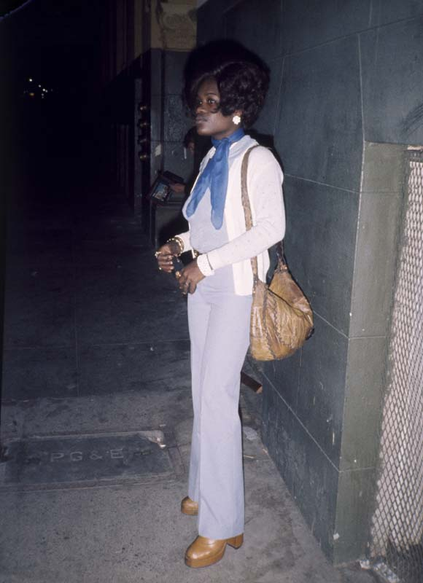 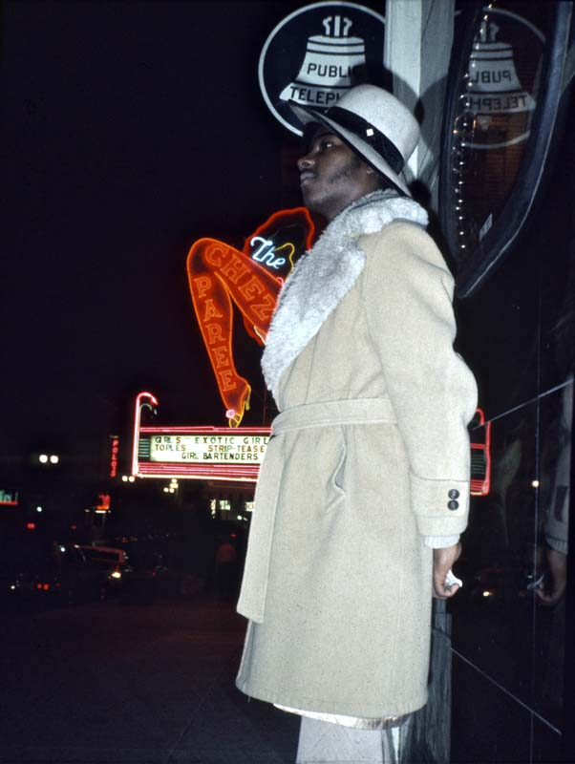
One of my friends from the building on the street outside and a pimp

9. On my new life with the prostitutes - now seen from above

As soon as I returned to the United States three years later as a lecturer, I felt that my sudden power had given me a different relationship with prostitutes and women in general. One of my first lectures was at the home of Jane Fonda in Santa Monica, where a couple of black invited Hollywood promoters were thrilled and immediately wanted to put my slide show up in 76 major cities, "We will put you on the Merv Griffin show, the Johnny Carson show... We will make you a superstar...... the women will love you.....etc."
But first they wanted to do a test screening in Hollywood for invited guests such as Marvin Gaye, Jesse Jackson and Muhammad Ali's family, as well as top people from CBS and NBC-TV. I was more interested in traveling the country first to see the reactions and get the approval of the people whose lower-class lives I showcased in the show. So when the black promoters said I had to take the segment with my black wife off the show, "because it just makes you look like another doo-gooder liberal," I got to thinking about my whole horrible time with Annie and the prostitutes in San Francisco, where I had just driven from down in Los Angeles. Annie, with her pain, had done so much to make me successful. Could I really so quickly throw her overboard and give in to the usual social controls of the blacks? So it slipped my mind that before the show for all the black celebrities, they could arrange a tryout for some of the underclass about whom the show was about. "What about, say, all the prostitutes in Hollywood?" I said jokingly at first because I knew it was impossible, but then bit down on the idea, even made me stubborn. Because I felt that by just saying yes to everything, things started to move too fast when it came to show business. But now I saw how there really wasn't much difference between Hollywood promoters and pimps, because the very next day they called me and said they had found a bar with prostitutes where it could be done. It amused me a little to think of all the years when black guys during my lone night wanderings in the black ghettos had come whispering to me, "Sir, do you want me to get you a girl?" or even worse when they yelled it out loud from across the street to ridicule me, "Hey, you wanna a woman, honkey?" in the eyes of the residents. Because everyone knew that only white men looking for a prostitute would venture into the black ghettos. It was all this, my former humiliating powerlessness, that I could now, in my sudden exhilaration of power, avenge by asking the counter-question of the promoters, "Sir, can you get me a bunch of girls?" to put them to the test of how much they were willing to put up for a bit of shitty mammon from a white man😊 But also to demonstrate that I wasn't prepared to sell everything out for a moment of fame.
So just two days after my show at Jane Fonda's house on Wadsworth Ave, I drove the 25 miles up to Hollywood to set up my equipment in the bar they found suitable. It took a lot of time, as there were only ring-shaped leather-covered couches around the round tables, so I had to run everywhere to stack suitable tables on top of each other for my half-ton of equipment. Then I went to a nearby restaurant to eat and wait for "git down time" when the prostitutes came out. I knew it would be late in the evening, which is why it could be a really long show if I managed to get the hookers really "hooked".
Also in my restaurant was a beautiful young black girl sitting all alone. I had never initiated with any woman before - let alone black - except Annie which as I said I hadn't got away with very much either. But in my sudden exuberance I now had the idea to invite this woman to my show for fear that the prostitutes would not come. As I had guessed, she was one of the many women who go to Hollywood to be seen and discovered, which with my sudden power I might as well do before anyone else gets the idea. So I asked her if I could invite her to "one of the best shows I know in Hollywood, you will really like it!" I didn't mention where it was, but when she asked for details, I told her it was "a musical based on a bestselling book" and showed her my Danish copy of the book. When she discovered I was the author, she immediately agreed to go. Sandra Jones was "a nice girl", so fearing that she would quickly run away when she saw the place and that it was not a real theatre, I first filled her with a few drinks and told her that it was only a test performance, but if she liked it, she was welcome to come and see it again a few days later with Muhammad Ali himself, Marvin Gaye and the other invitees. "Wow, I am all for the whole package," she replied enthusiastically.
We waited a long time, but later in the evening the prostitutes and some pimps slowly began to trickle into the bar. I won't forget the warm feelings that immediately rose up in me. It was like an overwhelming deja vue with the past to see their attire, their long bald wigs, alluring smiles and body language and I felt how much I had missed them in the intervening three years. Although I didn't know these women personally at all, I immediately felt a strong connection with them for better or worse - mostly pain perhaps, after all, but from a distance it's easy to repress and romanticize your pain and see only the bright moments I'd had with them in the closed world of the Tenderloin ghetto. Thoughts like, "How I love these women," ran through me and made me laugh at the banality of it. But perhaps most important was the overflowing love I now felt for them with my sudden artificial excess, a love that always shapes the recipient. I noted that it was a mix of streetwalkers like those I had lived with, but in this part richer part of Hollywood not quite so ravaged by drugs, and slightly nicer barflies. Still, among these human traffickers with their glowing meat pots, I had no idea whether I was bought or sold. I just hoped there were a few free "out laws" among them who would stay and watch the show and not, like the others, be chased out by their pimps when the first customers showed up. Mostly I prayed to the higher powers that there would be no customers at all on this weekday evening. In particular, the always restless, nervous pimps were in and out all the time, so I found it hopeless to try to introduce the show beyond a few words about how I had been hitchhiking around black ghettos for 5 years and that Alex Haley had seen what I was about to show them, "to see how you react". Then I just started the show and turned up the music so loud that it would be hard for them to just stand and talk to each other. Alex Haley, of course, was a huge name among all blacks at the time right after the world success of his "Roots." That Alex Haley had fallen asleep in my theatre in Denmark only half an hour after the opening music "Ship Ahoy" with the arrival of the slaves in America due to jetlag, as Haley had arrived the same day from the USA, I of course did not mention to the prostitutes. But the miracle happened, no white customers came for two hours, so these present day slave keepers saw no reason to whip their "ho'es" out in the field, and needed all the more a bit of appealing entertainment during the wait. And since many of them or their families had roots in the South, they were completely gripped by this first part of the show about modern-day slavery in the South. There was the deepest silence I've ever experienced in a bodega and it was obvious that the black men were feeling chaste and trying hard not to show emotion - especially towards something a white man had done. They began to seem to me quite small and human and no longer like fearsome "mean and tough pimps" the more they lost power and control over their women, which made it even easier for me to also think fondly of them without passing judgment. Occasionally the men went out into the street and I didn't think they would return. But some time later they returned with other black men whom they had invited to watch with them. I began to rejoice within myself. What power I had suddenly gained over these mother-locks of darkness, who had given me one of the greatest defeats of my vagabond years, when I had finally lost the ability to love both them and myself. It is no matter to achieve a loving relationship with each prostitute, but in piles you are dragged down by them. Now I had the surplus to cope with them in piles and perhaps even to be able to give them something - a redemptive help in understanding their lives - that I had not previously been able to. Jubilantly I recalled my grandmother's rag rug in the parsonage of my childhood in the words of Hans Christian Andersen, " Something good can come out of the lasers too, once they are off the rag pile and the transformation has been made to truth and beauty, they shine in good understanding and in it is blessing."

After two hours there was a break and I wondered if I should end my little human experiment here while the game was good with the redemptive music, "Now that we found love", that always makes Americans cry and stand and embrace each other. But now my own date in particular was pressing to see the rest and it was of course in the 2nd part "The Ghetto in Our Hearts" that I gave my interpretation of the cause of the crime, the prostitutes and pimps etc. that I had come to show them. So I ended up without a word and without a break to continue also because we had only started at 10pm - "git down time" - which meant that at best we would not finish until 2.30am if anyone stayed to the last.
And now the Lord granted me an even greater miracle, for when and if any white customers finally came into the bar, the black prostitutes lovingly persuaded them - as only a prostitute can do with her arms warm around them - to first sit and enjoy themselves over a few drinks and "listen to the good Marvin Gaye music on the show", after which the whites themselves became so hooked on the appetizers that there was no hurry to get to the meat dishes. And so, by mutual aid, we finally got to the section towards the end about the prostitutes, including the story of Geegurtha, which many of them could so strongly relate to, along with my intimate pictures of pleasure girls with their white customers and pimps, that there were immediately excited murmurs at the tables and even juicy shouts from a few. It was as if it was only then - in the fourth hour - that some of them remembered why they had come to the whorehouse that night in the first place, and then a few of them took it upon themselves to run away, perhaps because it was all getting a bit too close for comfort. But many stayed from first to last, which was such a victory for me that I was finally able to reach the unreachables that had made my life crumble at one point, that I myself had to stand and cry with weeping merrymakers in my arms as I watched the shadows of the embarrassed human traffickers in the darkness behind me. And if anyone had now been convinced that here was a product he could "pimp" in the American meat market, it was my black promoter.
I had almost forgotten my own date in tears of joy when I spotted Sandra Jones standing dissolved in tears in the background. So now that I had my empathy back, I couldn't very well be bothered to leave her in this sorry state, and quickly compassionately/compassionately suggested, "so how about "Coming home" with me?"
Hm, this impressed Hollywood aspirant Sandra even more, for it was my good fortune to have borrowed Jane Fonda's secretary's apartment for a week. For she had flown with Jane Fonda - an hour before my show was completely over at Fonda's house - to the Cannes Film Festival to present her new film, "Coming home", for which she won this year's Oscar. So "back home" in my borrowed luxury beachfront Santa Monica, we now amused ourselves in the late morning hours that the out-of-touch prostitutes had shown more patience with my show than the ever-cheeky Jane Fonda. And since Sandra didn't want to miss my next promised show with Muhammad Ali, well, we didn't actually get out of bed for a whole week - except when we were on the beach or she took me to a giant black disco at night on La Cienega, where we danced the night away. That's how you use prostitutes to get wonderful sex, I thought, even without spending a dime on it. And not only that, but I'll never forget how Sandra said she'd never had an orgasm before - and these were by no means fake, as I remember them. "Wow, it sounds like you're coming," I exclaimed in amazement at all the screaming. "Yes, I am 'coming home'," she both cried and laughed at the same time, which amused me here during the Cannes premiere of the film, which was about Jane Fonda's sexual love affair with a Vietnam veteran who was as disabled in that respect as I had previously felt. In other words, I could feel that I had entered a new era when I recalled the despairing or non-existent sexual relationships I had had with black women subject to social control in my vagabond years, when they could never help but signal in the most intimate moments that this was a relationship between a free and an unfree person, which caused us both to slow down. And in the eyes of better educated "free" blacks, I was just a drifter not worth betting on. Sandra was like from "out of space" - a new type of black woman who exuded freedom and self-esteem and who therefore didn't make me feel guilty about the interaction. Oh, how I loved that sense of freedom.

But the guilt soon returned for other reasons.
For when, after a week or so, we went to my big private performance for invited celebrities in a Hollywood cinema, it wasn't just Muhammad Ali's brother who was standing over my shoulders crying afterwards. No, I think it was his cousin who came on to me so strongly that if I hadn't had Sandra with me, she too would no doubt have succeeded with her star fucking.
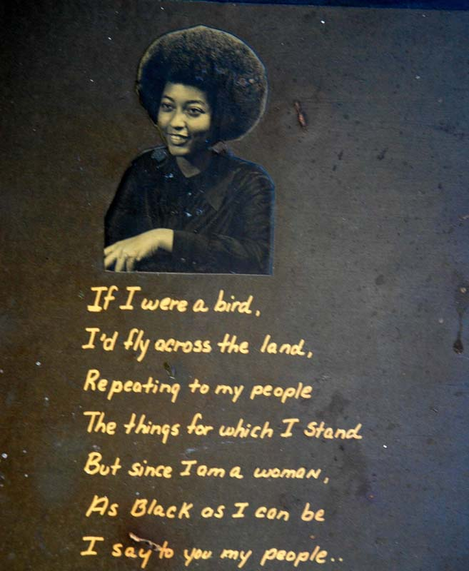
And even before that, another highly educated black woman had called me in Santa Monica and offered herself. It was the sister of my assistant in Denmark, Tony, Harriet Harris, who called to ask if she should fly out and help me with the legal side of the offers I was now getting from Hollywood. I had never met Harriet, only dreamed of her. For in my vagabond years her beautiful picture with big proud afro hair had hung on the wall above me in Tony's living room with a poem she had written for him:
”If I were a bird,
I’d fly across the land,
Repeating to my people
The things for which I stand
But since I am a woman,
As black as I can be,
I say to my people…
Stand Tall, be Black, be Free!”
She represented everything I had dreamed of in a highly educated black girlfriend back when I was only in contact with the ghetto's non-compliant poor women. Now she had heard from Tony that I had suddenly become something and threw it all away to fly all the way from Atlanta to LA to offer both her professional and carnal assistance.
So what else could I do but, from memory, answer the dream woman from 5 years before with her own poem, "Yes, I wish you as a bird will fly across the land, to help your people with the things for which I stand...." She was impressed with my memory and the next evening I picked her up at the Los Angeles airport, which was close to my apartment in Santa Monica. But before that, I had to brutally dump Sandra. However, we had both agreed that our relationship would not continue and that we would just enjoy each other as long as we could. Still, I hadn't expected it to happen so abruptly. And the punishment for my selfishness was immediate. For indeed, that very evening Harriet went straight to the meat of me before we had even talked about our legal collaboration. But it may well be that my long-standing dream of her immediately fell to the ground, for in the can we were not at all a match. And certainly not right after the paradisiacal love-fire that morning with Sandra.
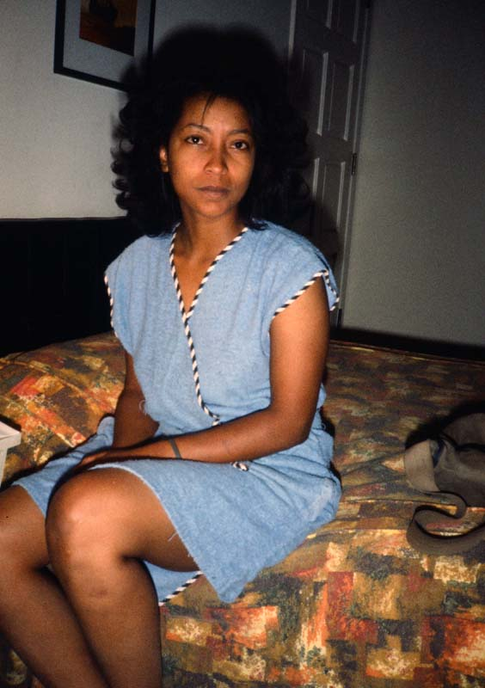
The explanation comes in the section "On saying yes to lesbians", but it was something Harriet in the black homophobia of the time would not face. So after several disappointing relationships with black men, she now dreamed that I would be the great white hope that Tony had pretended to her. But it was all good for something anyway and helped emancipate us both.
A lifelong lesbian friendship came out of it for me, as now in her disappointment (with me) she had to face her sexual identity and take the plunge fully.
Harriet Harris disappointed the morning after

At the same time, her unconscious contempt for men had given her a good dose of feminist thinking, which I could now draw on in our conversations about my own take on Hollywood sexism. For I was so appalled by the sudden power over women that my new stardom had given me in a few days that I had become - to put it bluntly - peasant, feeling downright peasant throughout this sophisticated meat market. Or at least felt that it would be best for me to keep both feet planted on the ground like a peasant. I felt pretty sure that if I went ahead with Hollywood I would not only sell out all my principles, but with my yes principles even be humanly destroyed by taking advantage of all the women who were apparently lining up to take advantage of my stardom. I had already seen in my vagabond years a number of millionaire friends exploit women individually in this class society's "marry to get rich" mentality, but not least the feminist and top whore Margo St. James had helped me to see how much it was all a mirror image of underclass human trafficking when this economic aspect in Hollywood was linked to power and fame. Here, even "the best and the brightest" were ready to sell themselves as whores to the producers. After only a week of stardom, I had already exploited two women and was ready to pounce on a third if the opportunity presented itself. It made me nauseous, but it was an important realization of my own dark shadow sides - a necessary wakeup call from the higher powers:
"Jesus said: "If you draw out what is in you, what you draw out will save you. If you do not bring out what is in you, what you do not bring out will destroy you." The Gospel of Thomas.
So in conversations with the otherwise sensible but, like me, dreamy and idealistic Harriet - through whose later daughter I would many years later move in with one of the world's most famous rock stars when she had the same problem marrying him only to be dumped - I quickly decided to escape from those cigar-smoking Hollywood promoters with their loud cigar stances in air-conditioned offices and especially from a president of Universal who would immediately sign me. After all the effort and money they had already invested in me and my prostitution experiments, I also felt guilty towards them. I excused myself by saying that I would first travel around to present the show to all those I had photographed in American Pictures to get their permissions, and then I would call them back. In my article afterwards in Information, I didn't then have the courage to admit that I had in fact already taken the tempting bait of Hollywood's "starfucking" prostitution circus.
I never called Universal back, of course, but immediately set about negotiating with lawyers, along with Harriet and her rights experience, for the music rights to the show. Hollywood would have done that for me otherwise. Now I had to pay for the whole thing myself, which was expensive. Then I had a nice "lesbian" drive with Harriet across America through the southern states, where after a 3-6 year absence I had a wonderful reunion with all the poor friends I had just come so close to selling out in my prostitution with Hollywood. Oh, how I enjoyed being down to earth again.
It was another 4 years before I returned to the US. I wanted to use American Images to create change here, but after my baptism of fire in Hollywood, hadn't been able to find the right way to do it. So the next time I took the entire black and white working collective from Copenhagen with me so that they could keep me in their ears in a concerted effort, and prevent me from once again spooning out in a one man show's carnal trappings.
And I was wise to do so, for in the years that followed, even in university academia, I repeatedly saw attractive female students who first tried to make a pass at me, but later left for Hollywood to try their hand at the men who possess real power. Whereupon I received several cries from them to come and rescue them from the swamp of prostitution, drugs and alcohol they had fallen into. But I also met a steadfast young girl who travelled around with me - sharing my bed with no desire whatsoever to achieve anything - purely because she was taken by my "film making with integrity". Funnily enough, it was exactly that woman with integrity who, many years later, made it to the top in Hollywood, where she has since produced and written many of the world's most profitable and best-known films. So let me tell you more about her later in the section - well, let me call it for now - "On saying yes to groupies". For it is this yes - with its great responsibility - that is so difficult for both men and women in power-based relationships. I would not venture here to say that I have never failed, but that I became more aware of the problem than perhaps many others is no doubt due to the fact that, out of sheer survival instinct, I became aware early on as a poor and experimenting vagabond of the importance of loving and honest inner thought and integrity. Without this, one easily becomes deaf and blind to the cries of need from the people with whom one associates.

10. On hearing the cry for help from prostitutes

In my university workshops, during long AA-like sessions, former or current prostitutes often suddenly opened up about their pain, but if I myself was too drunk on my external success, it just made me deaf and blind to them. I experienced a typical example when, in 1988, I had a Thanksgiving in this way that I will never forget. I had shown my slide show in the racist Detroit suburb of Dearborn. Already, when I had question time during the break, I had been annoyed by the tone of a white woman's questions, which seemed accusatory to me as if they sprang from an inner anger. In the elite schools for the children of the rich, I waded in success, understanding, and admiration, so when I suddenly found myself in the schools of the working class, I was sometimes knocked out by not meeting the same immediate sympathy there. Teresa, as the woman was called, did not express outright racism in her questions, but I sensed that they sprang from racism and became so annoyed with her that the rest of the audience felt it.
After the slide show there was a workshop and I remember my annoyance at seeing her again among the participants. And again I felt her accusations and became not only defensive but outright aggressive towards her in my voice. When we finished for the evening, the organizers suggested we go to the black nightclub, Snickers, in the ghetto of Detroit and as we packed up they asked "Why were you so annoyed with that woman?" "I can't explain it," I replied. But since Teresa hadn't left yet, I felt guilty about my behavior toward her and went to ask if she'd like to join us at Snickers - though without the slightest desire to see her anymore. She said that unfortunately she couldn't come as she had to go home and walk her dog. But while we were listening to a blues singer in Snickers, she suddenly called the nightclub and asked to speak to me. She asked if I wanted to come over the next day. I replied that I had a show out at Albion College, which is almost halfway to Chicago. "But after that I have Thanksgiving break and maybe I'll drop in," I replied without even the slightest desire to do so.
On the drive to Albion, however, I pondered what had gone wrong in the chemistry between us and concluded that she harbored a deep inner anger and that I would betray my own principles of being open and responsive to it. After all, anger and violence are always an attempt to get at you - just as she herself had demonstrated with her outstretched hand later that night. So two days later I drove the long way back to Detroit and asked if I could move in with her for the Thanksgiving holiday - again out of sheer guilt that I had mistreated her in the past - and even though I wanted so much more to spend Thanksgiving with a nice girl in Dayton, Ohio, who had invited me.

Staying with Teresa in a high-crime area with my expensive gear in the car was not without its problems, but we solved the problem by putting her big, beastly German shepherd out in the car at night to avoid break-ins. From now on, Teresa started to be more open without seeming accusatory towards me. She said she needed to tell me something she had never been able to tell her peers at school, but after seeing my show and the workshop she felt I would understand her.
After all, before she had started university, she had been a prostitute and in that role had advanced to the highest ranks as a "high class call girl." When I proudly noted that I had previously lived privately outside San Francisco with Margo St. James - the very leader of America's prostitutes - trust was immediately established, for Teresa had personally known Margo. She herself had serviced the finest businessmen and politicians, and mentioned several nationally known names among them. So skilled had she been that she had been the only call girl employed at a week-long summer camp for over 100 millionaires, bankers, etc. She pulled out a box on the floor and began showing me pictures of many of her former clients - all men in their prime and at the top of their careers, I deduced from the newspaper clippings and other sources - and frequently photographed with Teresa in a lavish lifestyle. She told me how, all these years, she had become completely addicted to this upper-class life of expensive dresses, cars, booze and, increasingly, pills and drugs.
All these were key words for me, which together with her accusing anger and trembling voice, which I had sensed earlier during my show, evoked a deep, deep pain. I sensed that this was developing into a major therapeutic session and that her previous anger towards me was just the usual clumsy cry for help. As the emotional slave I had always felt like, I had never really done emotional workshops like Tony at the time, but now took the chance and tried to man up to the best I had witnessed in them. Suddenly - as we sat over the pictures on the floor - I grabbed her hands and asked if she had been subjected to incest as a child, as I had enough experience with prostitutes to know that such abuse almost always underlay their later professions. The question surprised her as much as it did me, as I had not planned it, but after a long time of silence and brooding, the tears now began to well up in the eyes of this girl with the hard outer shell and I knew I had got the right end of the stick.
She was now telling of a terrible childhood in which she had been completely subjugated by her stepfather. Not only had he abused her sexually, but he had also crushed her self-confidence in every other way by always calling her "lazy, useless, stupid, ugly, etc." Such a pattern, I knew, opens up for further damage later in life. And when I asked if others had abused her, she told of several others in the family, including her brothers and grandfather. When she began showing me vacation photos from a road trip she had taken through the South with her grandfather, her tears turned to silent sobs. For the grandfather looked in the pictures like the most loving man and yet he had raped this now 10-year-old girl over and over again.

It was the classic example of oppression I had experienced so many times before; the initial incest and deprivation of self-confidence and sense of control over one's own life inevitably becoming an invisible stamp imprinted on her forehead, but obvious to any potential oppressor who has suffered similar harm themselves. So now I asked if she had ever been raped as a teenager. Surprised that I already knew the answer, she recounted two violent street assaults - one resulting in hospitalization. I may have read about it, but never had I personally experienced such a classic pattern of oppression of violence and abuse - leading to further violence and abuse - and slowly manipulating an increasingly powerless individual into the ultimate oppressive role of adult prostitute and drug addict. But all the time I had to painstakingly pull it out of her, because as always it was all hidden in layers of repressed memory and attempts to protect and excuse the perpetrators in the family who in the pictures looked so loving and ordinary. Each time I penetrated one of those pithy layers and brought the facts to light, her crying became more and more obvious until finally it became completely uncontrollable. For two days we sat like that on the carpet, rubbing each other, holding hands or each other and crying - me too because I couldn't help being moved.

Now I was curious to hear how she had come out of her decay as a whore for the upper class. She told me that one of the many millionaires, a lawyer, had fallen in love with her and through his long-lasting love he had slowly rebuilt some of her self-confidence. He had convinced her that with her sharp and well-developed tongue-tied, she could become a good lawyer herself and had helped her get into rehab and then financed her education. The fall from her formerly extravagant upper-class lifestyle to ordinary poor student had been dramatic - especially after their relationship broke down. She had moved into a poor area of Detroit, Indian Village, where she had been incessantly assaulted and robbed by blacks and had had her house broken into - again in keeping with the victimhood mentioned earlier. When she told me about all these assaults, she kept using the phrase "fucking niggers" by which she was now openly expressing the racism I had clearly sensed in her during my previous show although in the university atmosphere of political correctness she had not openly expressed it. But the phrase "fucking niggers" showed once again that racism is NOT caused by one's own relationship with blacks but has its origins in the abuse one has suffered early in childhood, in her case by being "fucked" by her entire white family. One day she had been burgled by her own brother, who had stolen all her most precious jewelry and all the family heirloom silver, and had suddenly understood - intellectually - that it wasn't "niggers" out to get her, but junkies. For junkies - black or white - are capable of doing anything to those closest to them. For her brother had himself been abused by the stepfather, stripped of self-confidence and then manipulated into the ultimate oppressor role like herself. But even though she had become best friends in her own rehab with a beautiful black woman (whom I met and who is now in my slideshow) who, after a similar upbringing, had ended up an alcoholic, - well, that didn't change the fact that Teresa's deep unresolved anger constantly made her express herself racist. That's why my and Tony's so-called "racism workshops" were always about anything but the narrow concept of "racism." Namely about the personal injuries we all carry around in different ways through life, which guide our behaviour and make us think and act negatively towards others.

If the experience with Teresa was so powerful for me, it was not only because meeting her gave me the opportunity to practice everything I had been teaching for years only on a theoretical level. No, it was because it was one of the few times in my life I truly felt like I was actively involved in fighting racism. Not just through empty talk, but through action. To be directly on the barricades of this struggle, as in the case of Teresa's redemption, is an incredibly beautiful experience, because in my opinion there is no other way to fight racism effectively than precisely through such therapeutic sessions. And going "to the barricades" in this struggle is only done with one's own life at stake - as I now experienced with Teresa. For in the process of redemption, which consists of slowly peeling away layer after layer of the hideous and harsh facades of chronic patterns of suffering one has acquired through life, one is in effect stripping the other person as well as oneself to reveal them in all their naked and original beauty.

I truly experienced this with Teresa. For this woman, with whom I had harbored such irritation and outright disgust during my clashes at university at the approach of aesthetic idiosyncrasy, became more and more beautiful in my eyes through two days of outpourings. Not only was I now able to see her inner beauty, but also her physical outer beauty. It goes without saying that as a former call girl for the upper classes she had to be both well-built and beautiful, but because of her deep anger I had been completely blind to this side of her. I had probably also become more beautiful myself through this process, in which I had given everything of myself - just as I had seen Tony become so time and again that everyone in his emotional workshops slowly fell in love with him. The result, in any case, was that - although fully clothed - Teresa and I sat like two almost naked people on the floor and fell more and more in love with each other. The fact that she, as a former call girl, was rather lax with her clothing towards me - especially at night when we slept in her big double bed - probably didn't make the situation any better for me. By the last day, which was Thanksgiving Thursday, we had achieved an intimacy with each other as a married couple. In gratitude for all that had just happened for her - the ecstatic feeling of liberation - she wanted to make a big Thanksgiving dinner for me and together we did the shopping and preparation all morning, looking forward to putting the finishing touches on this way.

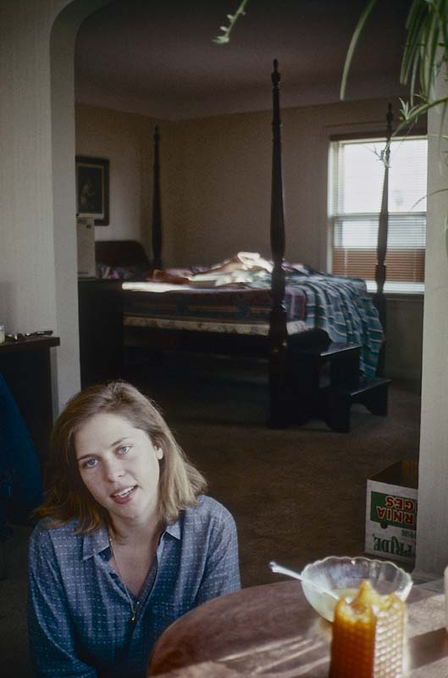
But in the afternoon I started to get more and more cold feet and shortly before the turkey was due to come out of the oven, I suddenly told her I had to go. I didn't need to explain further because she knew why, she said. Then I said a very quick goodbye to her so that it didn't end in any more crying and drove lonely off the motorway while she was left alone in her little house with a huge dinner, wine and candles lit all over the place. The thing was, like her, I knew this would develop not just into an innocent infatuation, but inevitably into an actual relationship - emotionally as well as sexually. And although I wanted one in every way, it went so violently against my long-held principles that I really had no choice but to tuck my tail between my legs. First, my old vagabond principle of never having sexual relations with the prostitutes I stayed with, as this would destroy the whole intimacy between us - even if with Teresa it was only a matter of a former call girl. And second, of course, the principle of not sexually exploiting the feelings of dependency that always arise between client and therapist.
Where I have mostly been able to live with "saying yes", there are situations that require an evasive unspoken "no" if you dream of maintaining your integrity! Today it is a "no" I am of course proud of, but let me confess that at the moment - faced with the female beauty who had physically and psychologically revealed herself to me over three days - it was not an easy choice the devil had given me. Since then, Teresa has become a lawyer in Atlanta, but although she has written and called me frequently, for some reason I have yet to return to the city where Tony and his lesbian sister, Harriet, also live with her former abusive partner, Norma, the angriest woman I have ever met. Perhaps there was a higher purpose to my escape back then. For in escaping Theresa that Thanksgiving, I instead ended up that same night in both a Jacuzzi and a waterbed with two lesbian girls - one deeply battered and bruised and all blue from prolonged violence - and thus in an equally therapeutic session that same night in neighboring Ohio. But that's another story that belongs in "On Saying Yes to Lesbians."
A not very good picture of Teresa with our bed behind
11. How I spent all my money on Jamaica's prostitutes

Saying no in such situations with prostitutes, however, is not always so straightforward and somewhere it ended up costing me dearly. Every year I had freshman orientation for the new students of the fine Ivy League Cornell University early in the month of August, but since the other universities started later, I had a few weeks off afterwards and spontaneously decided to go to Jamaica without a trace of preparation. It was out of a long-held desire to examine the difference between the impact of slavery on American and West Indian blacks, and why, despite their poverty, Westerners fared far better in my universities. As soon as I stepped out of the airport in Kingston, there were a couple of sneaky guys inviting me home. I didn't exactly fancy these two, but I didn't know anyone else and couldn't "say no" on principle, I thought. Everyone had warned me at home: "If you go to Jamaica, for God's sake don't go to Kingston. And if you end up in Kingston, for God's sake don't go to the ghetto of Trenchtown."
Now my "yes" took me straight to the lion's den of a slimy room in Trenchtown, where I had to share a bed with two gangsters with three others sleeping on the floor next door. It was steaming hot in August, but they didn't dare open the shutters to the street for fear other gangsters would shoot in. I had sold a lot of books in Cornell the day before and hadn't had time to get the money changed, so I lay with a four-inch-thick bundle of dollar bills under my pillow for fear they would see them. All night long, reggae music boomed from a prayer home next door while the hungry dogs of the street and the compounds glowed incessantly. Suddenly, at 4 a.m., a jeep slowed and drunken soldiers smashed the door with rifle butts. We were all chased out into the street in our underpants and up against the wall with our hands behind our backs and machine guns in our bellies as the soldiers searched the room. I knew the gangsters had a bag of marijuana, but the soldiers were too drunk to find it and left. The next morning I saw an incredible amount of anger in our compound, with the women walking around half-naked and screaming, their faces contorted in pain, beating the children and kicking the hungry dogs. How can you live in this hell all your life, I thought. Many of the men ran around with guns just like Jimmy Cliff in the movie "The harder they come". When I went out on the street, everyone warned me that it was too dangerous. When I finally pulled myself together to try to escape this nightmare of a sleepless night, I saw how much blood was on the sidewalk next to the neighbor's house along with what looked like placentas, so I assumed it was a maternity clinic, when suddenly one more was suddenly thrown through the bars, almost landing on my head. This was far worse than any American ghetto I'd experienced, even though several criminals - stoned on marijuana - poked me in the stomach with a gun, saying, "No problem, man, we don't shoot tourists in Jamaica, for we need you to come back with your money." Yeah, as long as they didn't find the whole wad of cash I was carrying.

I managed to escape up to the tourist town of Ocho Rios on the north coast, where I didn't immediately want to see any more people and checked into a cheap hooker hotel to get over the shock. Here I was safe and in the evening I went to a concert by the albino Yellowman - the world's first rapper with his sexually arousing reggae. In the queue, I was the only white person to strike up a conversation with the girl in front of me. It was enough to keep her occupied for the rest of the evening, so when after some time in the intoxication of ganja and loud music I fell madly in love with another black beauty in there, Verona Blake, I only just managed to escape the jealous woman for a moment to discreetly give a piece of paper to Verona to meet me the next day at noon in McDonalds, the only meeting place I could think of. Verona arrived exactly on time and immediately suggested that she cook dinner for me and after I bought in a chicken and some vegetables, we went to her house. I immediately noticed that she wasn't living in the miserable tin shacks like everyone else, and asked her what she did for a living since almost everyone is unemployed in Jamaica. She replied evasively, but I became even more curious when I found a box of books under the bed and discovered that she was well read in black American literature, including Angela Davis books, which were not exactly cheap books. After dinner, which I had paid for, she suggested that I move in with her. But in her compound I had recognised one of the prostitutes I had seen on the street earlier and so now suspected Verona of having acquired her relatively high standard of living through some form of prostitution. So, evasively, I said she could come and visit me at my hotel the next day and we could talk there about me moving in with her. I was utterly captivated by her charm, beauty and intellect - so it was good to get her a bit of distance. Now we started going out together for several days, but every night she ended up sitting in my hotel room asking why I didn't want to sleep with her. I have my weird principles, of course, and one of the ones I learned in the vagabond years was never to sleep with prostitutes - even when, as in this case, there was only flimsy evidence that she had gotten her money from rich tourists. Although she may not have been, I also had, from my first Afrikat, a principle of not having sexual relations with the natives. There, in The Gambia, I'd had an evening with an innocent "date," whom I barely had time to kiss. Yet years later in Denmark she called me and I realised that it is pure colonial exploitation for rich wealthy people to enter into relationships with Third World natives on such unequal terms. They cannot distinguish between love and the hope of escaping poverty through marriage.
In Jamaica, too, I knew that all they dreamed of was "a one-way ticket to the USA," where, unlike America's own blacks, they do as well as whites. But with Veronica's irresistible beauty and constant loving embrace of me, I must confess that I came close to giving in to my stubborn principles - not least when she was showering and preening under a jungle waterfall during a picnic. Or when she came and lay by my side during the day in my bed while I got the maid to keep her out at night.
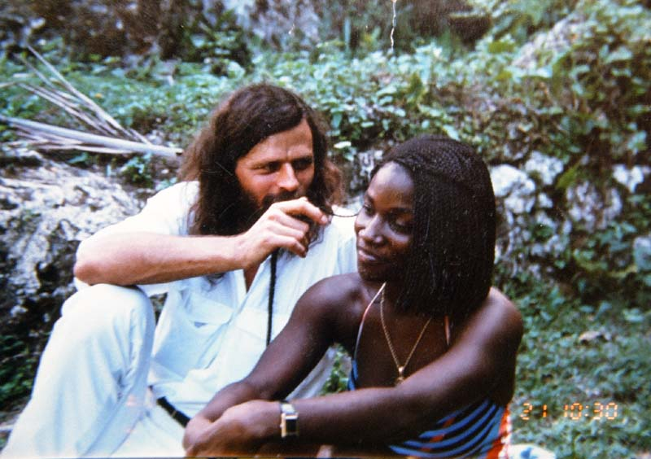
With the irresistible Veronika Blake on a picnic

But then one day she asked to borrow money to go down to her sick aunt in Kingston and of course I could do nothing but give her for the bus fare. During her absence it was rumored among the city's bedridden prostitutes that I had given her money, for the very next day another sweet girl with a huge puffy cheek came and asked me for money to go to the dentist. I couldn't refuse her help either, as the need was obviously urgent, but in return demanded to stay with her in her romantic 2 square meter little palm leaf hut, the smallest I had ever stayed in, where I took some beautiful pictures of her in a blue nightdress. Thus I paid my way out of sleeping with her, a business model I developed with small quid pro quos from their lives rather than their underbellies, which I soon refined to mutual benefit as I hate pure begging.
Day by day, more and more came asking for help. The thing was, in the middle of hot August, it was out of tourist season, so no one had any money. Soon word spread like wildfire among the town's prostitutes that I was the only man who could help them - even without sex - and within 10 days I had spent all my Cornell book money on them. But in return, I've rarely had so much fun.
The nights, however, could be almost unbearable. Several of the streetwalkers were so starved that they climbed up onto the foot-wide ledge outside my first-floor hotel room and stood there through the night, arms sticking through the tropical blinds, whispering incessantly, "Please let me in!" When I finally did fall asleep, I had the strangest nightmares about being wrapped in octopus’ arms. At first I swapped rooms with the maid, Gloria, who lived in the windowless cleaning room in the middle of the building with the cleaning products and brooms, but soon she couldn't stand the wailing of the tentacles through the plastic blinds either and moved into my bed - her own bed, that is. This developed into a strong relationship between us and I found myself increasingly attracted to her. She was no beauty revelation like Verona, extremely thin, but I loved her skin, which was as jet black as the room she lived in and only became a black blob when I photographed her against the white walls outside. Yet she radiated light unlike the menacing girls of darkness. If she had wanted to, I could easily have entangled myself in a sexual relationship with her, because unlike everyone else on the island, she was not for sale without me quite figuring out why. Because she was all over me because unlike all the other white men she had staying in her hotel, I wasn't interested in sex with the prostitutes. And the more unapproachable she made herself when I tried with my white squid arms to trap her in, the more attracted I became to her. The forbidden has always been the most exciting for me. If only to put her to the test, I tried in one way or another to conquer her. But no. So the day I left Jamaica, the only thing I bought her was an expensive gift, a nice wristwatch. "I want you to have it because you were the only one I met on this poor island who didn't let wealth and money corrupt her, and because you protected me so tenaciously from all those who tried to trap me the way I tried to trap you," I said, after which she finally let herself be caught in my arms and gave me a huge hug goodbye as tears welled up in both of our eyes.
I wondered later if by having worshipped her as Madonna inside me and like so many other primitive men I had merely expressed misogynistic contempt for the others as "whores". But by having felt sexually turned on by the innocent maid and not at all by the whores, I must be suffering, according to Freud, from a reverse Whore-Madonna complex 😊

"Where such men love, they have no desire, and where they desire, they cannot love." - Freud
Glorious to conclude that I was not driven by the basest Freudian instincts although in my anima obsession according to Jung's archetypes I revealed that I had probably not progressed beyond the (virgin) Mary stage. Anyway, I failed to integrate the inner and outer of this womanhood of mine and eventually had to flee my virginal little cleaning room when one of the most aggressive whores from the street managed to break in one night and another fell off the cornice and was seriously injured.
Indeed, the city's prostitutes were divided into a kind of upper and lower class. The fine sophisticates like Verona I was fine with, but just outside the city on the road down to Kingston lived a very aggressive and violent underclass of street prostitutes, which I tried to avoid also because many of them had cuts on their cheeks from their pimps. Probably they were the ones who tried in the dry season without tourists to get their women to rob me. These very betrayed and often drunken lower-class women made me feel guilty all the time because I felt that I was unconsciously trying to avoid them and favoring and loving the refined ones who knew well that violent and loud behavior towards tourists backfired. But if I was even thinking of helping anyone in this whole hellhole besides myself, it should have been some of the lowest and most oppressed in the social hierarchy that I should have targeted. .

When my wonderful maid in my otherwise designated whore hotel couldn't take their attacks from north, west and east any longer - and finally even from the cornice facing the lighted street - help came from just one of the upper-class prostitutes who had heard of me. It happened when, one day on the street, a tall, well-built woman suddenly began to question me about Plato's and Aristotle's views on pleasure girls while she stood outside a posh hotel, drawing. "Did you know that Aristotle had it written into the Constitution of Athens that the ten governors of the city should supervise the musicians and dancers at the male banquets to prevent the flute-harp and lyre-girls from getting more than two drachmas a night. For sexual services were to be part of their contract.
And did you know that Aristophanes uses the pleasure girls in The Wasps to attack the old men who sit in judgment of others but only think of pimping them for money. And that in his Symposium, Plato even has Aristophanes talk about Eros, about how man and woman were originally of one flesh. But then the gods thought up a way to split the person in two, so that you men would spend all your time chasing your better half and becoming one again. So why do I hear that you have such a strong reluctance to want to unite what the gods have destined us for from the beginning of time? Because unity is what this life is all about, don't you think?"

I was completely speechless. Here I stood in the worst humidity of August with sweat dripping down me and being interrogated in my knowledge of ancient evil by a poor black prostitute, so I instantly felt transported back to the sweaty exam halls of high school days and with the exact same guilt and reproach for not being able or willing to deliver the goods, not giving myself away.
But after a while I calmed down a bit and tried to answer for myself the best I could after 20 years of absence from the school bench. For Aristophanes in particular I had some knowledge of, as my Danish teacher had translated his satirical comedies and been a fan of his pioneering and saucy sexual shenanigans. The more elaborately he rendered them, the more he had, as a rarity, made me listen. So much so that I ended up giving a two-hour lecture on Aristophanes' "The Clouds" (the play that came after my prostitute's "The Wasps") to the class and writing an Aristophanes play about the class myself, which ends with the murder of my dance teacher. It almost cost me my entire career as a vagabond, as my Danish teacher Erik Madsen was the only one of my teachers who voted against kicking me out of high school after 2. g with the words, "Jacob has a good head if only he bothers to use it." Now a prostitute, like Madsen, made me confirm Seneca's ancient wisdom that one should "learn not for school, but for the underbelly."
For here, too, was apparently a feminist of Margo St. James's ilk, defending the role of pleasure maid and avoiding even being destroyed by this world's oldest profession by legitimizing it through her deep interest in philosophy in the style of "Lysistrates" women's revolt against the control and oppression of women by the ruling male classes.
How could I possibly resist such a strong and intelligent woman's brazen offer, standing on her feet - or rather just feet under her long well-turned legs - to put this weak man down too? But she had enough psychology to see through that I was not for sale just like that, so after a long philosophical discussion she said: "Well, I see you have no intention of taking me home to your hotel, so I guess I'll have to take matters into my own hands and take you home with me so we can talk some more. After all, there's no money to be made here in town right now anyway. Come and let me show you the beauty of Jamaica as I don't think you've experienced it yet. I have the Rasta name Unity, for unity is my faith."

She was a Rastafarian and lived several miles of beautiful nature hiking through jungle and waterfalls and over mountains in a wonderful bamboo and palm leaf hut on a sloping jungle and grass covered mountain overlooking the entire ocean, surrounded only by jumping goats and smoking Rastafarians with long locks of tangled Rasta hair. When I entered the hut, I was again struck with amazement, for the entire hut was filled with her philosophy books stacked in boxes along the bamboo walls. She told me that she had not been allowed to study in the United States and had become an upper-class bride solely to afford books. This was not hard to convince me of, for there was no difficulty in otherwise surviving here on her vast lush plot of land where anything could grow. Now, when I showed her my book with the pictures of American prostitutes as Geegurtha and told her that all the pain I had experienced among them was the reason I was against even sexually exploiting prostitutes, we had a good laugh about the fact that I had spent all the money from my book sales on Jamaica's prostitutes while she prostituted herself to afford all her books. "So don't you think we can make this work here?" Unity asked with a particularly seductive smile. I replied that I thought so, because I had a little trouble dealing with prostitutes in droves in ghettos like downtown. It creates disharmony and aggression and no sense of unity. But here with you, living in complete harmony and unity with your surroundings and your faith and your books, I am sure that together we will be able to achieve a greater unity, Unity, which will enrich us both. As for wealth, I was selfish enough to see what free wealth, indeed what paradise, I had fled to here. For no American millionaire, I felt, had ever owned such a wonderful place. 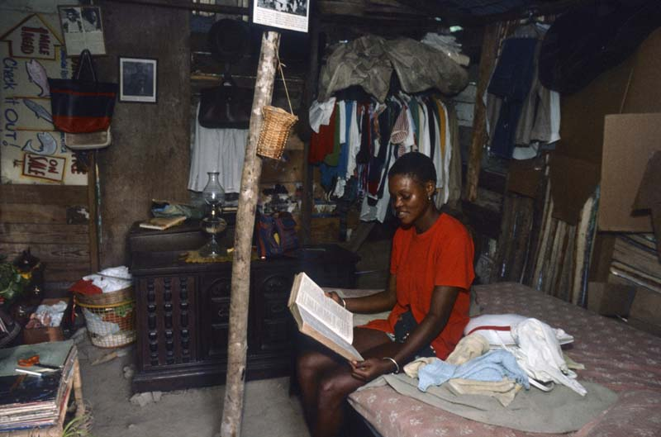
My new home with Unity the rasta, who had just cut his rasta locs.
"I'm moving in here," I said. And if I didn't have to go back to my shows in the States after a while, I probably would have stayed there until the end of my days. Because I almost felt like I had earned the right to move in with Unity. After all the ordeals I had gone through with the shaky start in Kingston's violent hackney yard over the nightmare of the nocturnal octopus arms grabbing at me night after night I had now advanced all the way to the top and had reached my Heaven - as I usually say it because it feels like that every time.

I did not forget my responsibility to the others down in the ghetto. I had promised one of the prostitutes to help find the American father of her child when I got back to the States. So on the way to the airport, I shared a bed with her and her child to get all the information and pictures of this white man in Brooklyn who had just run off after getting her pregnant. Now somehow in her eyes I became so hopeful that it could have easily happened to the two of us in the same intimate way, which made me reflect that the worst crimes are often committed under the guise of helping others. But these little wake up calls from above always have a positive side effect, because just to not see myself like him, who had fled from his responsibilities, I spent so much more time afterwards trying to find him in Brooklyn. For this is always the biggest problem with traveling in poor countries, that you promise to do everything for people who give you so much of what little they have, but then forget it as soon as you get home and skate on down the road with your frivolous ego projects. Right after Unity's philosophical defense of prostitution, it was thus important to be reminded that there are victims too.
Before I had fled to her little heaven, I had also fled the sex ghetto in other directions. Among other things, I had hitchhiked to the much larger tourist paradise for Americans, Montego Bay. Here, a long-dead whore invited me to share her bed in her shabby tin shack on a hillside threatened by constant soil erosion, but with a view down to the luxurious white tourist hotels. As the photo shows, it was all she had to show for her years of serving Americans. Much of the night was spent with her telling stories by the light of the oil lamp about all the painful experiences she had had with her customers throughout her life. So it might actually be good before you feel tempted to go into the flesh of the young beautiful prostitutes just for a moment to share terms with the old ones first to get the whole perspective.

I had actually gone to Jamaica to study the racism of it all but will get into that in "On Saying Yes to Racists." But one of those with whom I have remained friends ever since, Bruce Gipson, put it as clearly as the racists of the South, that while he had no relationship with blacks in the United States, he loved the blacks here in Jamaica and returned again and again. I became such good friends with him that I was allowed to photograph him in bed with up to several of his prostitutes at a time, and he took Veronika and me on a picnic in his rental car, taking the picture of the two of us together, which clearly shows how tempted I was by her charm and beauty. So I don't want to judge anyone with this chapter. What would Jamaica's poor live on without Americans like Bruce? And what would he himself, a poor white man in America, live on without being allowed, day and night, in Trump's casino in Atlantic City, to deal the cards at the well-padded tables of the rich?
Because they can't live on me spending all my book money from a lecture on them. And this is exactly what my printer Per Nørhaven in Viborg complained about. When I returned to the reality of the United States, I begged him to give me a little respite from "paying your big book bill, because I just spent all the money on the prostitutes!" So he too now made me feel very guilty, as he usually printed 15,000 books at a time for a bill of half a million dollars. But the dollar was low at the time and I had just that year started letting ghetto criminals and a few prostitutes sell my books in an attempt to give them an alternative livelihood. But they turned out to be just as unreliable payers with just as many bad "outings" as myself. So Jamaica's prostitutes just about tipped the whole load for me.
But as I have since said to Per Nørhaven, "It is more fun to buy books for the prostitutes than to fill mansions with them. And you got your manor anyway for all our prostitute efforts for you. So now I think it's only fair that I use your manor for luxurious accommodation for me and my fellow Muslim girls on the lecture tours 😊"
And a long-suffering man like Nørhaven could only agree, since he also appreciates well-read female beauty in his beds.

More pictures of Jamaica's wonderful prostitutes

12. My attempt to help prostitutes ended with my escape from them

As can be seen, I have always found it difficult to answer how I feel about prostitution, since as a feminist I support women's right to decide over their own bodies and have met plenty of particularly "out laws" who are psychologically able to cope with the consequences of their choices. Conversely, as a feminist, I cannot look passively on oppression of women that victimises them. The problem, of course, is always to distinguish where the line is between the two extremes. Although Theresa declared that she herself had chosen the role of call girl for the upper classes, it turned out - when I took the time to dig into her past - that it was in fact not a free choice and that she was thus, from first to last, a victim who needed help. For the most part, I had simply had the power and energy to provide that help in the form of individual talk therapy and empowerment through my presence, when I wasn't too thick-headed and distracted to overhear the cries for help or - as in Jamaica - overwhelmed by the pile of cries for help. But like the case with so many other groups one wants to help, such as drug addicts, criminals, radicalized people, incest victims, etc., one always dreams of being able to do it in a more institutional way, which requires money.

I had that opportunity when I took Anitha Roddick, the multi-millionaire founder of ”The Bodyshop”, on a tour of the black ghettos because she wanted me to help her spend her money constructively on the poor. More on what came of that in "On Saying Yes to Millionaires," but when she met some of my black prostitute friends we got to talking specifically about helping them. However, she felt utterly powerless in the face of the crushed black underclass and instead had the idea the following year to send me to Nepal, where she saw more hope after travelling to source the ingredients there from the natives. As our first "joint business venture," she sent me to show Am. Car. for all the trekkers wandering the mountains with nothing to do in the evenings in Kathmandu. The money from the performances would go to Nepal's prostitutes to fight AIDS, which was exploding among them. The idea was so crazy that I immediately said yes. What else could I do? Here I had been skating the American highways for 25 years without making myself useful. Now I could get the support of a world-renowned social activist to make me a little useful - and get a free paid trip at the same time. I wanted to see a bit of the world outside the ghettos of America. As usual, selfishness is justified in the name of a higher idealism. For it was a crazy idea to send me around the world to rescue some prostitutes I had never known, while I had known - indeed piles of them in the US - without so far having made any serious attempt to "rescue them". But then I wasn't the only one travelling the world to save others. I had just given a talk at the UN summit in Copenhagen on social development, which for the first time emphasized "human dignity". Well, there was sleeping US Vice President Al Gore, Fidel Castro and all the other climate destroyers flying over the heads of millions of poor people to talk about their "human dignity". No, now Anita Roddick wanted me to act instead of talk, so the day after the summit I travelled to Nepal to show for The Body Shop. And it sounded good when I tried to convince them that I wanted to fight human trafficking with money from a "Body Shop" 😊
The proceeds from my lectures in a theatre in Kathmandu would go unrestricted to an AIDS awareness campaign among Nepalese women and help for prostitutes and I was delighted. I had often missed something that could benefit others more concretely than just being a mover of thought.
I really had butterflies in my stomach when I went to a new continent, Asia, for the first time in my life. Feeling that I had become increasingly rigid in my Western ways of thinking, I had lugged over 10 kg of Buddhist literature with me. After all, I had the largest library of black literature in Denmark, and with all my time-wasting travelling among blacks, I hadn't read so much as one of the books yet. So I was really looking forward to relaxing with some reading as well, but it was not to be. The gods had other plans for me.
Elegantly printed invitations with gilded royal letters had already been sent out to prominent government officials for the gala premiere, where King Birendra's family would be in attendance here just six years before the entire family was murdered. But apparently the king was not in control of his subjects, for no provision had been made for Nepalese customs, which did not want my old worn-out equipment to enter the country. All my heavy equipment had already arrived in Singapore but could not enter the country without permission from customs. In Western countries I would have just rented some local SLRs and brought only the image boxes, but here I knew I had to bring everything myself and then hope there was power to run the machinery.
And apparently there was no one else to do it, so I had to go out myself - night after night, sitting on the back of mopeds with a bottle of whisky under my arm - and negotiate with customs officers in mysterious dark slums. First the under-tellers, then the middle-tellers and finally the top-tellers. And each time it cost me more and more bribes in money and whisky to rise through the ranks. When I saw these slums, teeming with whores, I understood why these customs officers had no other way of making a living in a country with no tax revenue. Several of the customs officers were apparently pimps on the side, for the pleasure girls swarmed in and out. And as they expected me to pay for the large meals "before we can get down to business", during which I had a little too much whisky, I ended up spending several nights on the blankets before we "got down to business". However, it was a great experience - here far away from the luxurious ghetto of white tourists inside Kathmandu - to experience this parallel world that most tourists probably don't see. And especially with crossed legs on thick blankets to have the opportunity to penetrate a little bit to the people behind the "customs officers and sinners, " which I was fed in my childhood church without anyone explaining if they even existed. But although some superficial fans had occasionally claimed so, I soon realized here that I was no Jesus after all. After all, Jesus was amazingly good at integrating sinners with tax collectors in his parables, so that the whole thing added up to a sinless higher whole. But for me, the attempt was a complete failure. I wondered if it was because Jesus only "gorged and drank" with them (Luke 7:2) and did not share bed and floor with them and down there in the dust and fleas experienced how troublesome they really are that he was able to speak so beautifully in pictures about them. No, come down to photographic floor level with them and see if they then turn out as beautifully. But one thing I had to agree with Jesus about - once again - is that it is no good trying to tackle toll collectors and sinners in heaps, because then you will soon fall exhausted in their laps. No, I learned here from the Hindus, you ride your moped with only one sheep at a time slung over your shoulders, just as Jesus carried it on the altarpiece in my father's church, and after the sheep has been cooked, he delights all his neighbours with it .....if they have been lucky enough to find a drunken sheep's head like me to pay for the whole feast.

"If one of you has a hundred sheep and loses one of them, does he not leave the ninety-nine in the wilderness and go after the one he has lost until he finds it? And when he has found it, he puts it happily on his shoulders, and when he comes home, he calls his friends and neighbors together and says to them: Rejoice with me, for I have found the sheep I had lost."
(Luke 15:2)

Thus, when, after many costly excursions that cost me more and more, I had worked my way up through nicer and nicer quarters on the back of night mopeds to the very head of the over-the-top and under-the-general-war-commander¬general of the entire customs service and negotiated an acceptable price to get my equipment into the country - though he could not promise that it would arrive in time for the day of the grand gala premiere - he then discreetly asked, but revealing and important question about whether I had enough money to get my equipment out of the country again. And since he was not willing to negotiate a price on this in advance - "before I've seen what it is you're bringing into the country" - I realized right away that I would be left with no guarantee that they would not take millions for me to ever get my equipment back.
In other words, I had to bitterly admit that against these bunch of whores and pickpockets, the battle was lost beforehand, for I couldn't do without my show gear and had to sadly get BodyShop to ship it home from Singapore instead. My whole idealistic project to "save" Nepal's prostitutes had fallen flat because they and the customs had literally eaten and drunk it up in the all pervasive corruption. And probably they themselves were fully aware that they were getting far more out of it that way than if my collected money for them had gone through the entire royal gilded board that was in charge of this gold framed project.
It may be hard for today's youth to comprehend that time only 20 years ago, because today any asshole could have just smuggled my entire show in and out of the country on a well-worn memory stick. But then I probably would have been sitting alone in a crappy hotel and not having such baroque and insightful interaction with the poor, where the insanity of my whole ego project slowly dawned on me. Again, one can learn more from a few nights with sinners and tax collectors than from a thousand Buddhist or "Culture shock Nepal" guidebooks brought along.
For it would be sheer madness now - just as it was 17 years earlier in Hollywood - to abuse the power given to me by my artistic product to indulge again in power-crazed paternalism over women. Although the idea of using this unearned power - like another Robin Hood - to redistribute money and power from the rich to the poor seemed fun and tempting, the idea of polishing one's own gold-rimmed glory by ransoming women seemed to me just as tasteless as buying women. And besides, bottomless as only a white man could have conceived it, I found out by having just a little contact with the noble savages whom I had set out to "save" by proselytizing among them. For even if, with royal help, I could have procured some hand ears from the rich for these women, well, I was not in a position to ransom them from their slavery, but only by a little AIDS prevention to make them still more attractive to the rich men, and thereby molbo-agously to trap them still further into slavery. For the money was to come from the members of the higher Braham, Chetri and Thakuri castes and go especially to the "untouchable" prostitutes of the casteless Dalits and Badis. And never even in the white supremacy of the US had I seen such insane racism in prostitution before. For according to the rules of orthodox Hinduism, these supremacist castes must not let Badis and Dalits into their houses, must not accept water or food from them, must not use the same village pump or even brush and broom as them. Yet they are no more "untouchable" than the upper castes' men are allowed to have sex with these casteless prostitutes. One of these "rejected" women said that for many years she had thought it was her religious destiny to be a prostitute, but now she was beginning to realize that this whole system was not made by the gods, but by men. So I began to realize that the reason these men, along with the Chetri members of the royal family, now didn't mind my support was that the "untouchables" might become a little more "touchable" in their eyes if I helped make them "clean" and HIV-free. Sure, I've always loved bringing opposites - black and white - together in dialogue and understanding with each other, but aren't there limits to the madness? All my previous discussions with people about how prostitutes are "victims" seemed completely meaningless here, where these women are taught from childhood that it is their "destiny" to be forced into prostitution - with no choice whatsoever. Soon it dawned on me that more than a quarter of a million of the underage sweet girls I had seen and photographed in the temples are, according to the sacred religious practice of Devadasi, being systematically sexually abused as prostitutes by members of the dominant castes, who can maintain their social status and economic control by linking prostitution and slavery with such brainwashing arguments. Similarly, most girls and women in Nepal and India's brothels come from Dalit and lower caste, tribal or minority communities. Indeed, the export of coveted fair-skinned Nepalese women to darker India and darkened Arab oil states was Nepal's biggest customs-declared export - or so this gigantic trafficking across all borders goes in this thoroughly corrupt country in which everyone seemed to get a piece of the pie - except the women, who were sold into years of remote slavery.
Faced with this institutionalized trafficking, I would have had to be a "Master of the Universe" to make a difference, and I didn't have such high obsessions about myself as a white man. So I ended up running screaming away from this whole underworld of "toll collectors and sinners", but felt myself enslaved out here by a return ticket several weeks later. Not wanting to play the ordinary tourist after my disappointment, I called home to my boss, Niels Tofte, at the overseas organization CARE to see if he had anything useful I could do out here. And Niels always knew how to save money and how to make me prostitute myself over 26 years by doing unpaid volunteer work for CARE. So he immediately replied back, "Well, Jacob, if you dream of doing something for Nepal's trafficked women, I can deliver." And so he sent me out into the most beautiful mountainous areas of Syangja, where I waded into piles of the most beautiful women. Again, it was like going straight to heaven here on the Himalayan bright hillsides after experiencing the barrenness and darkness of the slums.

The road on earth
to the high halls of Heaven
twists and turns
Through valleys of shadow;
Grundtvig

"Heaven", I had to say again, is only to be found here on earth among the beautiful people we say yes to being seduced by. All I had to do was photographically "flirt" with these beautiful women, and I did so with such ecstasy that my layout woman, who on her return had to choose from among all the beauties I had captured, exclaimed enthusiastically, "Jacob, you have literally raped all the women of Nepal." Yes, I excused myself with a bit of a peasant tone, "but I actually went there to protect them from being raped and then just lived in their sad reality. It was a choice between custom follow or land flight😊 "

Because here in CARE's way of working with the women, I saw the whole solution to the prostitution problem. Only by giving these women, oppressed for centuries, the empowerment and "human dignity" that male government officials from misogynistic countries everywhere had been yawningly talking about
at the UN Social Summit, would give these poor rural women the power they needed over their own lives, so that they were not forced or sold into urban slums. And this was done by CARE's women staff in village after village getting them together in "bunches" for women's meetings, where they talked about their problems with each other under informed guidance - without a single man present - except for me to document it. Needless to say, I couldn't help but feel in heaven to see them sitting here in the light, holding hands, on the hillside of the deep shadowy abysses I had just witnessed their fall into. And what made them so beautiful - unlike the trafficked women in the depths of the abyss - was not just their wonderful colors, but the inner strength and pride I saw them exude the longer they had worked on their liberation in these therapeutic group sessions. One after another of these women, whom I had seen elsewhere as cowed, evasive, shy and ashamed - or, in short, repressed - now stood up and gave proud speeches about their lives. These were very much about their struggles with men, and so I wondered why they were allowed to attend these women's meetings at all. But the genius of CARE's methods was that they were first able to win over the men by funding the water pipes and dams they would jointly build with the women to save their entire threatened existence on the overpopulated and eroded hillsides. In this way, CARE also persuaded the men to take care of the children at night while the women walked away from home on paths and dykes through the irrigated rice fields. It made a huge impression on me after a hard day's work - night after night - to see them walking in the pitch dark with oil lamps in hand to be enlightened in CARE's literacy programs. For in the countryside, typically, only the men had learned to read a little, and the path to equality, self-esteem, empowerment and child-rearing could only be achieved through the education of women. Only in this way, through long-term relief work and education, could the young, poor women be prevented from being forced into prostitution in the cities, I could see immediately.
Some of the highly educated women leaders from the cities told me how privileged they felt here in their mud caves, even though they could only afford and find the time to go to Kathmandu once a year to join their families' celebrations. For in the cities, as highly educated people, they had first found meaningless work in the government's destructive corruption and, as members of the upper castes, had learned to look down with contempt on the poor and peasants. But by setting in motion all these liberating forces among the peasants, and especially the oppressed women, they now discovered how much they themselves had to learn from them in the endless village meetings, and had for the first time gained for themselves a sense of equality by seeing it grow in others. So despite their enormous deprivation, they themselves had become happier by finding meaning in life.
I will tell you more about my work with CARE later in "Saying Yes to the Poor Countries II", because I could not but wholeheartedly support their emancipation processes. Indeed, I felt happier working anonymously with CARE - forgotten by all - than being constantly in the centre and being cultivated during my lectures. And I had experienced how corrupting it had been - not only on the lives of others, but on my own - that I had gone around the world to play the man of the world in the belief that I could save others. Overseas aid should not be given by sending rich white men to enlighten the poor unenlightened, as this only makes them feel even more inferior and thereby creates greater psychological divides in the world. No, it must be provided by the natives themselves - through the encounters and mutually enriching dialogues between country and city, educated and uneducated, men and women. For only in this way can equality be created and the great divides in the world be bridged. Or as I like to say, "The only white men CARE needs to send out are photographers like me. After all, we're not there to work for the natives, but to convince our rich compatriots back home to support this important work with donations."
That's how selfish we all are, and how we love to play the world's saviours of the oppressed for borrowed money. But thanks to CARE for rescuing me from the corrupting quagmire I had fallen into in the name of good.

And then perhaps it is only fair to add that when Niels Tofte sat at home with his high cigar stub, gloating that without spending a penny he had once again rescued me from the swamp by promising me "lots of women", he heard from his staff that I had become so popular among these women, that in village after village they garlanded my sinful head with flowers (and thus gave me some glory in the midst of my much-needed anonymity), well, he telegraphed before leaving and said, "Jacob, while you're out there on the other side of the world, could you go on to our projects in Thailand? Because you know they have an even bigger problem with poor women being forced into prostitution."
Well, Niels Tofte knew exactly which buttons to push by using praise from women to get me to prostitute myself for him for free once again, even though he was now offering to pay for the ticket. But this time I didn't want to start from scratch - with the prostitutes in the urban slums - but flew straight to the heights to be flowered by the very different but equally colorful women of northern Thailand's hill tribes. Here I immediately fell in love with a pipe-smoking woman with gold rings on her feet, who I stayed with in a bamboo hut on two-meter-high poles in the jungle. And it was well repaid, because when I woke up in the morning, she was ready with a loving smile by my side with a wicker tray full of live caterpillars, beetles, worms and a big fat toad. As soon as I opened my eyes she threw them into a mortar and mashed them into a delicious black sauce, boiled it a little and then poured it over a bowlful of sticky rice and pushed it over to me with the most loving look. Never had I felt anyone put my "yes policy" to such a severe test. I really didn't want to hurt her feelings but kept dragging out "our relationship". Then suddenly there was a terrible noise outside and her whole post house shook violently. I went out with my camera saying, "I'll be right back," and then discovered that it was an elephant that had saved me from a toad. The boy on the elephant waved at me, "Hop on," and it was an offer much easier to accept, so I immediately fled into the jungle.

But sooner or later, it was time to descend from this newfound Heaven to see the cost in the cities of not helping these women. So before I left, I wanted to visit the famous Thai prostitutes in Bangkok. Here, among the dark glass facades of skyscrapers, I felt the same bland alienation as in rich Costa Rica, which a few years earlier made me flee to the wonderful but poverty-stricken Nicaragua of far more sexually vulnerable women. I didn't understand why millions of tourists come to Thailand every year, but tried with an open mind and heart to plunge into the sex industry that drives so many here. But going out in Patpong was not for me. If I had wanted to come wandering with a prostitute in my hand, well, it was as if mother-in-law had sent spies after me everywhere. "Hey, Jacob, what are you doing here?" I heard everywhere from my former male students. And then you quickly lose the desire to give the prostitutes "a helping hand". But having seen so much betrayal among prostitutes in other countries, I was interested to find out to what extent they are just as destroyed by the profession here. I found a more unfamiliar and to me anonymous area of Bangkok where I spent a few pleasant evenings with them. There were actually many who were quite nice and natural. First of all, they didn't have the pushiness that many Americans have. I could easily sit a whole evening with them and enjoy myself without anyone starting to lay a hand on me. One prejudice I quickly eradicated in my mind: if you have immersed yourself even a little bit in Thai culture, it is impossible to see them ONLY as poor rural victims forced into the cities as portrayed in moralizing Western media. They can easily find themselves telling such tear-jerking stories to Western ears, which we can use as an excuse to get our wallets out. Just as effectively, they learn Danish, Swedish, Arabic or whatever kind of customer they specialize in. An incredibly pretty girl I spoke to had been to Odense and could reproduce an impressively accurate street picture of the city. When we became a little better friends the next evening, it turned out that she had never been there, but had merely learned such an accurate description of the city, and incidentally had excellent full-time employment in a laundry, but was merely bored. No, if they are victims of anything, it is a Thai culture that makes it as natural for some years to be a prostitute as it is for men to become monks for a time. Then they retire as housewives without the slightest condemnation from their surroundings.

The extent of this sex industry dawned on me on one occasion. One day I was walking in the sweat-drenched midday heat on my way to the National Museum and a young girl came up and chatted casually with me in the street. She was a tourist from Chiang Mai, she said, and since we were both tourists, she suggested we go together. As always in Thailand, I felt something was sticking out when I met humanity, but why not? A little later a nice red sports car stopped and a girl in it shouted if we didn't want to come. My new friend said she knew her and that we could get around to more museums if we drove. It was a really hot girl driving, and you'll do anything to get some air conditioning. I was offered cold drinks, but immediately remembered the signs warning tourists against stunning. And they had delicious food in a fridge in the car, but I made up another evasive excuse. We drove around and saw some pagodas from the car, and then suddenly, without a word, they drove at high speed across the river to a district where I knew there were no tourist attractions. Far out in this part of town we turned abruptly into a huge underground parking garage. I immediately had associations with Harrison Ford thrillers. Inside the base we drove up into one of the huge sex motels and then down past the long rows of curtained rooms. Everywhere there were men in sunglasses waving us on. There wasn't a single room available, even in the middle of the day. We continued up to the second floor, where the hundred-plus rooms were also occupied. On the third floor we were also waved on, and only on the fourth floor a man stood at one of the garages and waved us in and pulled the curtain behind the car. The girls jumped out and told me to come in. Inside the sex motel room, they signaled for me to wait while they themselves went into the inner room - probably to take off their clothes. I stood for a moment looking at the strange instruments and machines inside. Having just been in Pol Pot's torture chambers the day before, I could vividly imagine what kind of limb-reading I might now have to undergo. Suddenly I panicked and ran out through the curtain past the guard wearing sunglasses. Not daring to run down the long lanes on the floor for fear of being chased by the other guards, I plunged down a flight of cement stairs and into one huge laundry room after another, where hundreds of wives stood washing sheets. Eventually, I managed to run out through the lower parking garage and hide in a "Seven Eleven" shop further up the street. When I finally got myself together, I couldn't help but laugh at the thought that I had just escaped from a couple of otherwise cute and obviously highly educated girls only half my size. Such a scaredy-cat, I thought, and was actually annoyed that I hadn't had the courage to see what else would have happened in their torture chamber. I wondered once again what it is about the plutonic forces within me that on the one hand are constantly attracted to prostitutes as people - especially those who are obviously plutonic and victimized themselves - while I am constantly fleeing from them as people - especially if they don't fit into my conceptual world of plutonic and signal that they don't need the care of the goodness industry - or are too broken to signal anything at all.

I experienced just the latter when I chose the following year to go back to Nepal to work with the large ghetto of untouchable Dalits down in the lowlands towards India. But it was the saddest group I had ever worked with. Left loveless both by the outside world and mutually by each other, I failed to force a life-giving smile out of a single woman - here living literally like rats and by eating rats - unless they "chose" to be sold down the river into India's sex industry.

13. Conclusion and my opposite ends of prostitution

As can be seen, I refrain from taking a moral stand on a subject that will always exist, since I have always had friends among all those involved - traffickers as well as trafficked, customers as well as clients - and have been able to empathise with the human being. I experienced this not least when, in my old days in Denmark, I made friends at each end of the spectrum. One was Annie Fønsby, who had been convicted of making millions running eight brothels under a "roughing it" law that I don't think I'd even known existed. I don't remember even hearing about her case, as I don't usually read the colorful magazines and follow the lives of celebrities. That I hadn't been following it now became my strength when Annie and a friend called me up during a Christmas party at CARE and asked if I would like to meet her at a bar. It didn't exactly sound like one of the usual cries for help with the clink of glasses in the background, but I followed my instinct to say yes and broke up from the Christmas party to meet her. And it was a strange meeting, because we both felt immediately attracted to each other. When I asked what she was doing, she told me that she was in prison, but was home on weekend leave and now just wanted to have a good time with me. As usual with criminals, I did not ask why she was in prison, as the prisoners are already convicted and do not need to be judged again by me, but just need to be treated as fellow human beings. Perhaps this was what Annie had already heard about me and felt attracted to as she had met enough condemnation in the media. I don't remember how I first heard about her "ruffianism" because it's not something we ever talked to each other about. Only I have since heard that it was not about trafficked women, but about "well-treated women" who chose of their own free will to enter her safe brothels rather than the dangerous life of prostituting on the streets. But maybe Annie and I are just equally naive on that point and so to speak deserve each other 😊
So we started hanging out when she was on leave, and while my wife was on vacation in India she invited me home for dinner just down the street in Østerbro so I could walk my dog, which she loves. Together with a friend she shared an apartment with, she had made a really delicious dinner and we had a great time with a bunch of wine. Several times she asked if we should go to Tenerife together when she was released. Wow, I thought, it's not every day I get an offer like that from a really sweet and fit 25-year-old woman. Late at night I made signs of breaking up, but she begged me to stay, "No, let's just share another bottle of wine." To which I objected that we had long since run out of wine in the house. Never mind, she said, I'll get some. "Well, everything's closed at this time of night." Don't worry, she said, and made a quick phone call. And sure enough, a few minutes later a couple of cute rockers came driving all the way from Hvidovre to deliver two bottles of wine. I was impressed. Never had I met a woman who, while in prison, was prepared to use rockers to hold on to me. This was truly a woman who could make men work for her too! So it was really late before I even worked my way home.
Six months later came the day of her release and although I was holidaying at the cottage with my wife, Annie insisted that I go to the giant "release party" her friends had put together at the Lake Pavilion. You had to come in costume, which of course I didn't have at the cottage, so I went to my cellar just near the pavilion to find some suitable attire, perhaps my old Ku Klux Klan suit, but all I found was my father's old clergyman's dress. And in the meantime, having found out the truth about Annie's former sinful life, I wrote one of the Bible's forgiving quotes about harlots on the outside of a Bible, which I piously approached with. For I thought it was just a fun little private social gathering. But it may be that I was surprised at how famous Annie Fønsby was, when I walked down the long red carpet in this outfit with all the tabloid press snapping away with cameras on both sides. And Annie, who I had come to please, was nowhere to be found as she was surrounded everywhere in her silver glittering, provocative outfit by other celebrities. I tried as best I could to hide in the crowd before quickly tucking my tail between my legs as best the clerical gown would allow. But too late. The following week I was in the tabloids receiving a storm of protests from Denmark's priests, who certainly hadn't learned much forgiveness from their Bible towards sinners like me and Annie.
My own moral of this is probably simply that if Annie was as big a sinner as she had been made out to be and convicted of, she is also as much a human being as any other sinner in need of our forgiveness. And with the luck I had in not knowing anything about her beforehand, I would have been able not to emit the sinful, condemning thoughts about her that one cannot help harboring somewhere inside oneself when one follows and is influenced by a condemning society's writings about people. For I know how I myself develop judgmental thinking towards Muslims, for example, when I constantly hear only bad things about them without knowing them personally.
That at some point - despite her devilish tendency to say "COYOTE" like Margo St. James, and despite her former life surrounded by celebrities - she needed this, I think, was the reason why - without me knowing about it for a long time - she had posted a cute little video of her thoughts about me on YouTube. This is how I have always experienced Annie Fønsby as an exceptionally warm and kind person, whom I had asked a long time before to set aside the day for the premiere of my cinema film. When the day finally arrived, however, she hadn't turned up, so I rang her and she replied, "God, Jacob, I'd completely burnt out that it was today. I'll be right there." Whereupon she threw the kids and everything away and came all the way to Grand Bio in a taxi from somewhere in North Zealand and joined my "release party" afterwards.

There Annie could also have met my friend at the other end of the spectrum, Dorit Otzen. Dorit and I did a little human trafficking once, when her husband, Per Marquad Otzen, fell in love with my girlfriend, Berthe, when I was living in my backyard slum in Vesterbro before the US era. So Per moved in with me and took over Berthe, but brought their two-year-old daughter, Nadine, with him. (All three are seen in my small film here). When I was studying for my exams, I got annoyed at having a noisy child in our two small rooms, and in protest moved out to Per's wife's place in Vanløse and took her over. And then we might as well become lovers and it was a happy time, fertilizing each other's ideas until I left for the US. In the years that followed we maintained a close relationship after Dorit had now started the Nest to help prostitutes. It was a huge success and Dorit became the spokeswoman for prostitutes everywhere in the media. I'll never forget all those wonderful mornings when I woke to the radio news to her sweet, gentle voice crawling back under the duvet to me. Often now I met her with suitcases on her way to international conferences on the growing problem of human trafficking. But although she came to all my parties, I never let anyone know that we had once been lovers. To me, she appeared so innocent and upright in her important work that I didn't want to risk tainting her good public life by being associated with my far-from-blameless life with all the wrong people. That is why I did not show up at the Nest in Vesterbro.
But then her 60th birthday came with a big spread in the papers and I thought I'd drop by with a bouquet of flowers for her at the Nest "from an unknown admirer of your great work." I guess it couldn't hurt her, since I was expecting a lot of other worshippers on this day, among whom I could hide while just discreetly letting her know I'd been there. So it may well be that I got a huge surprise when I arrived. For one thing, I was the only man present, and Dorit wasn't there at first. But I was immediately surrounded by a sea of excited and clapping prostitutes and staff shouting into each other's mouths, "Here comes Dorit's girlfriend. How fantastic. Dorit has told me so much about you. How happy she'll be." To my surprise, Dorit herself had never made a secret of the fact that we had once been lovers, and it sounded to everyone as if they still thought we were. When Dorit finally arrived, she too was therefore not a little surprised to see me sitting single on the sofa with a bunch of prostitutes in my lap. It was a fantastic day and for both of us it was like the culmination of a long journey through the world of prostitutes, with my frustrated dream that I should have made a difference myself, which I now saw - and especially heard from the cheering 'happy girls' - that Dorit had been able to make a reality. As lovers in 1969, we had felt each other fertilize - she with her ideas as a social worker and I by collecting people in my slum - including her husband and daughter. So I went home happy that day and proudly made a website about how we were old lovers.
But I was somewhat sadder - although there was a huge turnout with speeches by ministers, KVINFO and staff from near and far, as well as Per Marquad Otzen and their now grown daughter Nadine, from whom I had fled at the time - on the day Dorit, at 70, ended her life's work with the Nest, saying in her own speech,
"Yes, Jacob, we both have to admit that our life's work failed. Despite your fight against racism and mine against human trafficking, both only got worse."

With this sad realization, I'd better end this not exactly cheerful chapter of my life with the confession, after meeting my first prostitute in Nyhavn, that you don't have to use your abdomen to have fun with these all-sacrificing pleasure girls. That's why I was not a little angry when a member of the Nobel Prize Committee of the Swedish Academy, Lars Forssell, in his high-profile review of my book American Pictures, sabotaged it in Dagens Nyheter with sentences like this:

"Like many observers of America before him, I think Jacob would rather see a peculiar future country in which injustice continues and justice prevails, where crime is widespread as now but where egalitarian hollyhocks also flourish and - above all for young Jacob - where prostitution continues but where woman still occupies her rightful position at man's side!
For Jacob "loves black prostitutes", which is not surprising since they constantly invite him to night lodgings and free sex.
Holdt's wild love and flaming hatred of America is, in its inconsistency, akin to Americans like Jack London and Henry Miller: a pinch of Marx and two spoonfuls of Nietzsche and, in Miller's case, at least eight teacups of DH Lawrence."

That my shoddy travel book was obviously not up to Nobel Prize standard I knew, of course, but that a man who sits around handing out literary Nobel Prizes is incapable of reading shocked me. Only two pages of the book are about the relationship between pimps and prostitutes and nothing about my relationship with them. And nowhere in the book do I say anything about having sex or sleeping with prostitutes. That sentence says more about the American lover Lars Forssell, who, on the basis of a few pictures of half-naked black women, immediately thinks of prostitutes in the best American way. Not even Geegurtha had the courage to write that I had actually lived with, let alone shared a bed with. Now that Lars Forssell is dead and, to my astonishment, a street in Stockholm is named after him, I finally dare to tell the truth. Perhaps instead I will share it with the venerable Swedish Academy, which at the time of writing is disintegrating from within due to the sexual assaults of its members on each other, a scandal that a little more gracious and noble dealings with real-life prostitutes might have prevented.
But even in the 40 years that have passed since Lars Forssel's devastating "fake news" attack on me, I have to conclude that he was never right either, as I have never had a sexual relationship with a prostitute.
What I may wonder about, even in this time of declining potency, is that I never had the courage to try such a sexual relationship. If only to show some solidarity and understanding for those men who feel they have no other choice. For when I have often enough experienced and felt the pressure, for example from gay men opposite me, it is perhaps a little arrogant for a man who has always been favored by the gods with ample opportunities for what Forssell calls "free sex" and conversely perhaps a less needy inner need, to play morally, precious and holy at the expense of these men. Especially in much of the world, where it costs many cows and goats to buy legitimate sex with a wife, who is then also often forcibly "sold" into eternal sanctioned rape. But even here at home, many men with the great libido our Lord endowed them with would feel utterly ostracized in the Lord's field by women with hearts of stone (as these men see it) if some self-sacrificing "goddesses" did not lovingly choose to bestow upon them their hearts of flesh (Ezekiel 36:27) - and thereby perhaps be able to also "ransom" the other women from further Incel attacks by frustrated men (Incel=involuntarily celibate). Hm?
One thing is certain, we will all be losers if we start heartlessly condemning any of the parties to this ancient historical human trafficking.
But as Søren Ulrick Thomsen said to me during a lecture holiday with him and Jørgen Leth in Crete, "The difference between you and Jørgen Leth is that Jørgen is the ultimate aesthete while you are the ultimate ethicist."
Py ha for a panoptic prison to imprison oneself in, I thought. How much easier, funnier and freer it would be to be Jørgen Leth.

Pictures for this entire chapter

